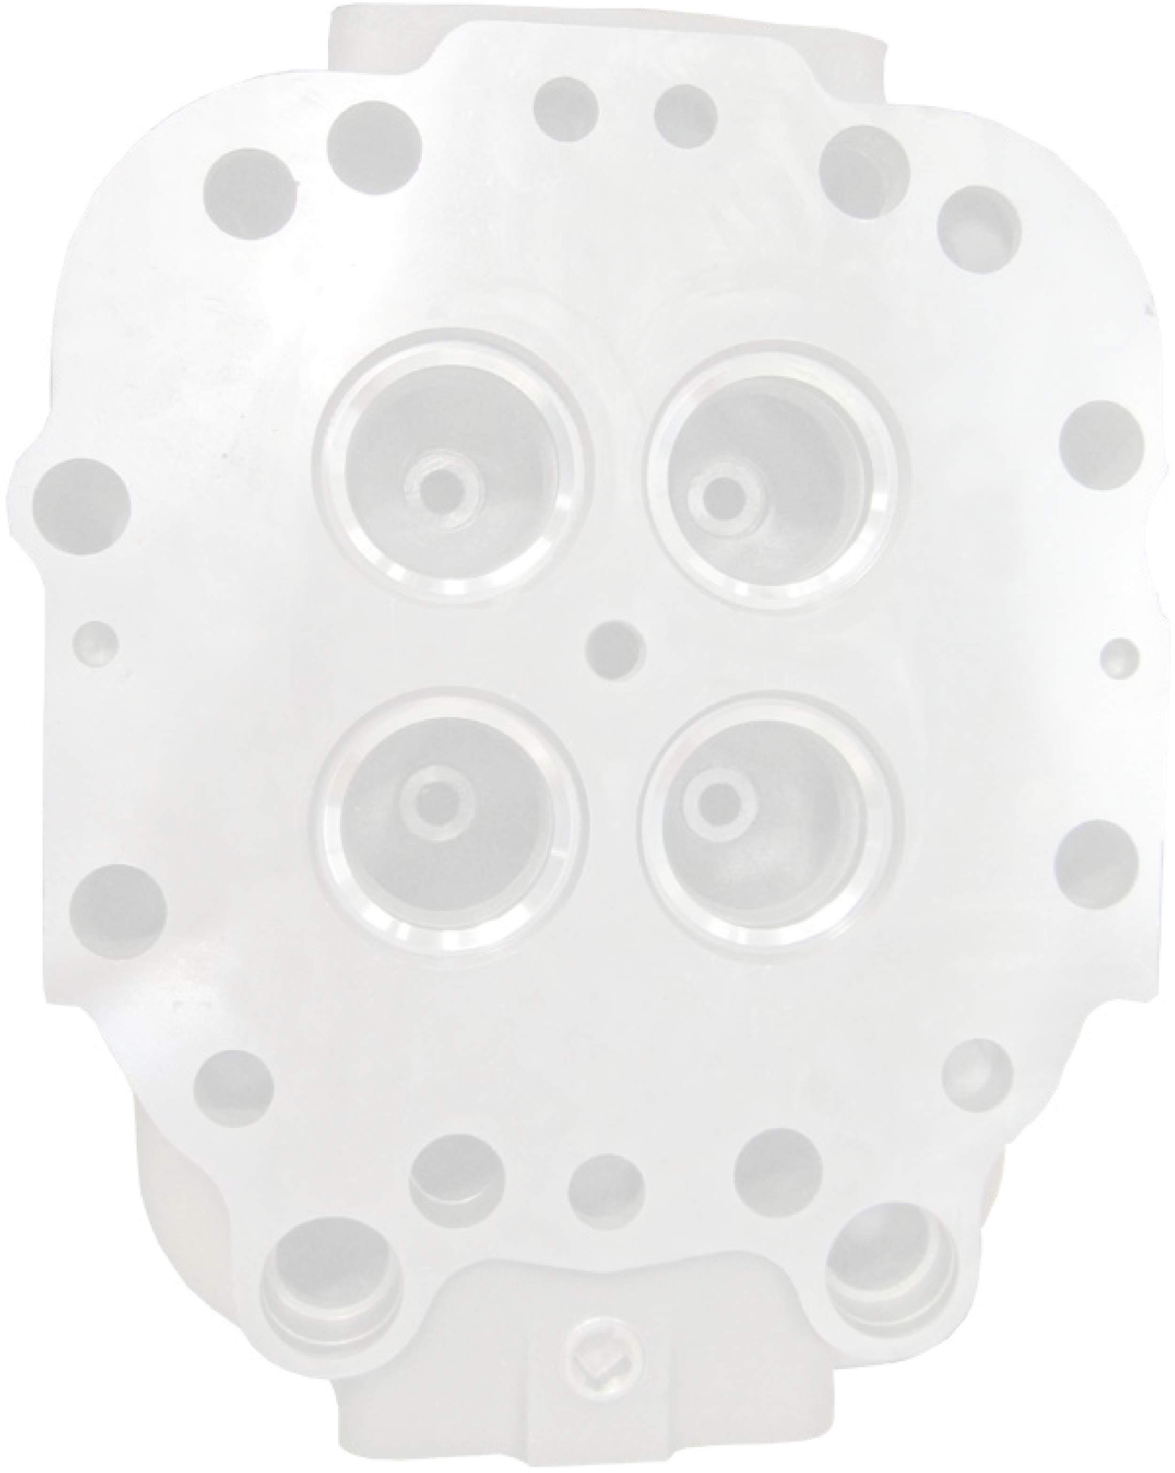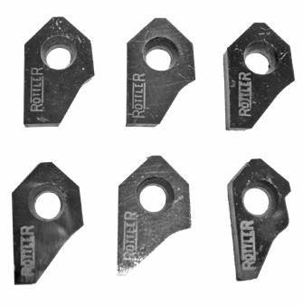

8029

S 200th St, Kent, WA 98032 USA | Ph: 253-872-7050 | Fax: 253-395-0230 www.rottlermfg.com

12.09.2019

# ORDERING PROCEDURE

Contact your regional Rottler sales rep for assistance in ordering optional equipment, replacement parts, or tooling.

If you are unable to contact your regional Rottler sales rep, call the factory at 253-872-7050 and ask to speak to the parts sales specialist.

Have the following information handy to expedite the ordering process:

1. Your name, business name, and contact number
2. Customer number
3. If you don’t have a customer number, your billing address
4. Shipping address if different from billing address
5. Machine model and serial number
6. Part number and description of what you want to order
7. Preferred method of shipment

You may also contact us via e-mail with the above information. Send e-mail requests to: parts@rottlermfg.com or intlparts@rottlermfg.com

In some cases you may be requested to send a photo of the part you are ordering if it is a replacement part, or doesn’t appear in the database.

If you are unsure which part you need to order, contact our service department and ask to speak to one of our service consultants. They will assist you in determining which part you require.

THERE IS A MINIMUM ORDER OF $25.00

# Contents

## Rottler Cutter Inserts 1

RCA Profiles 1

RCA001 Carbide Seat Insert 30-45-60 / 12 -10 1

RCA002 Carbide Seat Insert 30-45-60 / 20 -10 1

RCA003 Carbide Seat Insert 30-45-60 / 12 -13 1

RCA004 Carbide Seat Insert 30-45-60 / 16 -13 1

RCA005 Carbide Seat Insert 37-45-52 / 20 -13 1

RCA006 Carbide Seat Insert 30-45-52 / 20 -13 1

RCA007 Carbide Seat Insert 37-45-52 / 18 -15 1

RCA008 Carbide Seat Insert 15-45-60 / 18 -15 1

RCA009 Carbide Seat Insert 30-45-52 / 18 -15 1

RCA010 Carbide Seat Insert 30-45-60 / 20 -15 2

RCA011 Carbide Seat Insert 30-45-60 / 30 -152

RCA012 Carbide Seat Insert 30-45-52 / 12 -16 2

RCA013 Carbide Seat Insert 30-45-60 / 12 -16 2

RCA014 Carbide Seat Insert 30-45-60 / 14 -16 2

RCA015 Carbide Seat Insert 15-45-60 / 16 -16 2

RCA016 Carbide Seat Insert 30-45-52 / 16 -16 2

RCA017 Carbide Seat Insert 30-45-60 / 20 -22 2

RCA018 Carbide Seat Insert 30-45-52 / 18 -16 2

RCA019 Carbide Seat Insert 15-45-60 / 20 -16 3

RCA020 Carbide Seat Insert 30-45-52 / 20 -16 3

RCA021 Carbide Seat Insert 30-45-60 / 20 -16 3

RCA022 Carbide Seat Insert 30-45-60 / 30 -16 3

RCA023 Carbide Seat Insert 30-45-60 / 30 -18 3

RCA024 Carbide Seat Insert 30-45-52 / 12 -19 3

RCA025 Carbide Seat Insert 30-45-60 / 12 -19 (Caterpillar 3500E Intake seat Profile) 3

RCA026 Carbide Seat Insert 30-45-60 / 16 -19 3

RCA027 Carbide Seat Insert 30-45-52 / 18 -19 3

RCA028 Carbide Seat Insert 30-45-52 / 20 -19 4

RCA029 Carbide Seat Insert 30-45-60 / 20 -19 4

RCA030 Carbide Seat Insert 30-45-70 / 16 -20 4

RCA031 Carbide Seat Insert 30-45-75 / 16 -20 4

RCA032 Carbide Seat Insert 30-45-60 / 06 -22 4

RCA033 Carbide Seat Insert 30-45-60 / 20 -23 4

RCA034 Carbide Seat Insert 30-45-60 / 20 -25 4

RCA035 Carbide Seat Insert 25-45-60 / 14 -10 4

RCA036 Carbide Seat Insert 25-45-60 / 18 -10 4 RCA037 Carbide Seat Insert 35-45-52 / 16 -10 5

RCA038 Carbide Seat Insert 35-45-55 / 16 -10 5

RCA039 Carbide Seat Insert 35-45-60 / 16 -10 5

RCA040 Carbide Seat Insert 30-45-60 / 20 -13 5

RCA041 Carbide Seat Insert 30-45-60 / 10 -13 5

RCA042 Carbide Seat Insert 30-45-60 / 10 -14 5

RCA043 Carbide Seat Insert 30-45-60 / 18 -15 5

RCA044 Carbide Seat Insert 30-45-60 / 14 -15 5

RCA045 Carbide Seat Insert 25-45-60 / 14 -16 5

RCA046 Carbide Seat Insert 25-45-60 / 18 -16 6

RCA047 Carbide Seat Insert 30-45-60 / 10 -16 6

RCA048 Carbide Seat Insert 30-45-60 / 20 -17 6

RCA049 Carbide Seat Insert 30-45-60 / 16 -18 6

RCA050 Carbide Seat Insert 30-45-52 / 08 -19 6

RCA051 Carbide Seat Insert 25-45-60 / 14 -20 6

RCA052 Carbide Seat Insert 25-45-60 / 18 -20 6

RCA053 Carbide Seat Insert 30-45-60 / 12 -20 6

RCA054 Carbide Seat Insert 25-45-60 / 14 -25 6

RCA055 Carbide Seat Insert 25-45-60 / 18 -25 7

RCA056 Carbide Seat Insert 30-45-60 / 18 -10 7

RCA057 Carbide Seat Insert 37-45-52 / 20 -10 7

RCA058 Carbide Seat Insert 25-45-52 / 19 -16 7

RCA059 Carbide Seat Insert 25-45-52 / 23 -17 7

RCA060 Carbide Seat Insert 15-45-60 / 10-15 7

RCA061 Carbide Seat Insert 25-45-60 / 14-15 7

RCA062 Carbide Seat Insert 30-45-55 / 13-20 7

RCA063 Carbide Seat Insert 30-45-55 / 203-151 7

RCA064 Carbide Seat Insert 32-45-60 / 10-80 8

RCA065 Carbide Seat Insert 25-45-60 / 10-10 8

RCA066 Carbide Seat Insert 30-45-60 / 15-20 8

RCA067 Carbide Seat Insert 30-45-60 / 14-30 8

RCA068 Carbide Seat Insert 15-45-60 / 10-10 8

RCA069 Carbide Seat Insert 15-45-60 / 10-20 8

RCA070 Carbide Seat Insert 30-45-70 / 80-13 8

RCA071 Carbide Seat Insert 15-45-60 / 145-15 8

RCA072 Carbide Seat Insert 15-45-60 / 145-20 8

RCA073 Carbide Seat Insert 15-45-60 / 18-12 9

RCA074 Carbide Seat Insert 15-45-60 / 20-15 9

RCA075 Carbide Seat Insert 30-45-60 / 10-18 9

RCA076 Carbide Seat Insert 25-45-60 / 10-14 9 RCA077 Carbide Seat Insert 25-45-60 / 14-12 9

RCA078 Carbide Seat Insert 12-45-75 / 14-15 9

RCA079 Carbide Seat Insert 25-45-52 / 14-15 9

RCA080 Carbide Seat Insert 25-45-52 / 16-10 9

RCA081 Carbide Seat Insert 30-45-60 / 20-14 9 RCA082 Carbide Seat Insert 30-45-60 / 60-22 10

RCA083 Carbide Seat Insert 30-45-60 / 20-22 10

RCA084 Carbide Seat Insert 30-45-60 / 12-12 10

RCA300 Carbide Seat Insert 15-30-45 / 10 -13 10

RCA301 Carbide Seat Insert 15-30-45 / 20 -13 10

RCA302 Carbide Seat Insert 15-30-60 / 20 -13 10

RCA303 Carbide Seat Insert 15-30-45 / 14 -15 10

RCA304 Carbide Seat Insert 15-30-45 / 18 -15 10

RCA305 Carbide Seat Insert 15-30-60 / 20 -15 10

RCA306 Carbide Seat Insert 15-30-45 / 12 -16 11

RCA307 Carbide Seat Insert 15-30-45 / 18 -16 11

RCA308 Carbide Seat Insert 15-30-52 / 18 -16 11

RCA309 Carbide Seat Insert 15-30-45 / 20 -16 11

RCA310 Carbide Seat Insert 15-30-60 / 20 -16 11

RCA311 Carbide Seat Insert 15-30-60 / 22 -1611

RCA312 Carbide Seat Insert 15-30-45 / 20 -18 11

RCA313 Carbide Seat Insert 15-30-45 / 10 -19 11

RCA314 Carbide Seat Insert 15-30-60 / 20 -19 11

RCA315 Carbide Seat Insert 15-30-45 / 12 -20 (Caterpillar 3500E Exhaust seat Profile) 12

RCA316 Carbide Seat Insert 15-30-45 / 20 -20 12

RCA317 Carbide Seat Insert 15-30-60 / 20 -22 12

RCA318 Carbide Seat Insert 20-30-45 / 30 -38 12

RCA321 Carbide Seat Insert 20-30-52 / 16 -10 12

RCA322 Carbide Seat Insert 0-30-60 / 20 -15 12

RCA323 Carbide Seat Insert 15-30-60 / 18 -15 12

RCA324 Carbide Seat Insert 15-30-60 / 22 -15 12

RCA325 Carbide Seat Insert 20-30-60 / 30 -15 12

RCA326 Carbide Seat Insert 15-30-60 / 14 -20 13

RCA327 Carbide Seat Insert 15-30-60 / 18 -20 13

RCA328 Carbide Seat Insert 15-30-60 / 18 -25 13

RCA329 Carbide Seat Insert 15-30-60 / 20 -25 13

RCA330 Carbide Seat Insert 15-30-60 / 14 -25 13

RCA331 Carbide Seat Insert 15-30-60 / 14 -18 13

RCA332 Carbide Seat Insert 0-30-60 / 20 -28 13

RCA333 Carbide Seat Insert 5-30-60 / 20 -22 (Cummins NH Series Cylinder Head) 13 RCA334 Carbide Seat Insert 15-30-60 / 14-15 13

RCA335 Carbide Seat Insert 15-30-60 / 10-12 14

RCA336 Carbide Seat Insert 15-30-60 / 14-30 14

RCA337 Carbide Seat Insert 15-30-60 / 20mm (0078) - 20mm (0078”) 14

RCA338 Carbide Seat Insert 15-30-60 / 20mm (0078”) - 446mm (0180”) 14 RCA339 Carbide Seat Insert 15-30-60 / 18-15 14

RCA340 Carbide Seat Insert 15-30-60 / 14-30 14

RCA348 Carbide Seat Insert 10-30-60 / 264mm - 216mm OFFSET Insert (For Detroit 53 Series Head) 14

RCA400 Carbide Seat Insert 30- 375 -60 / 14 -16 14

RCA401 Carbide Seat Insert 30- 375 -60 / 20 -16 14

RCA402 Carbide Seat Insert 30- 375 -60 / 14 -19 15

RCA403 Carbide Seat Insert 30- 375 -60 / 20 -20 15

RCA404 Carbide Seat Insert 18- 375 -52 / 06 -21 15

RCA405 Carbide Seat Insert 15- 375 -60 / 14 -16 15

RCA406 Carbide Seat Insert 20- 375 -52 / 12 -18 15

RCA407 Carbide Seat Insert 15- 375 -60 / 14 -16 15

RCA409 Carbide Seat Insert 0-35-75 / 10-25 15

RCA411 Carbide Seat Insert 37 degrees’ / 93mm 15

RCA418 Carbide Seat Insert 10-20-60 / 36-305 15

RCA426 Carbide Seat Insert 5-20-60 / 25-15 16 RCA439 Carbide Seat Insert 30-40-60 top, seat width 080 16

RCA451 Carbide Seat Insert R5-35-50-65 / 165-43116

RCA500 Carbide Seat Insert 15 degrees / 77mm 16

RCA501 Carbide Seat Insert 20 degrees / 88mm 16

RCA502 Carbide Seat Insert 30 degrees / 90mm 16

RCA503 Carbide Seat Insert 45 degrees / 89mm 16

RCA504 Carbide Seat Insert 45 degrees 15 ‘ / 80mm 16

RCA505 Carbide Seat Insert 60 degrees’ / 81mm 16

RCA507 Carbide Seat Insert 75 degrees / 83mm 17 RCA511 Carbide Seat Insert 94 degrees 08 / 12mm (SHORT PROFILE) 17

RCA512 Carbide Seat Insert 94 degrees R 08 / 153mm 17

RCA513 Carbide Seat Insert 94-R05 / 25-65 (OFFSET FOR COUNTERBORING SMALL SEATS) 17

RCA521 Carbide Seat Insert 25 degrees’ / 85mm 17

RCA522 Carbide Seat Insert 70 degrees’ / 77mm 17

RCA524 Carbide Seat Insert 82 degrees’ / 707mm 17

RCA525 Carbide Seat Insert 94 - 60 / 80mm 17

RCA526 Carbide Seat Insert 45 degree / 984mm 17

RCA527 Carbide Seat Insert 37 degree / 929mm 18

RCA528 Carbide Seat Insert 35 degree / 95mm 18

RCA537 Carbide Seat Insert 50 degree / 89mm 18 RCA540 Carbide Seat Insert 40 degree 18

RCA541 Carbide Seat Insert 10 degree 18

RCA547 Carbide Seat Insert 15 degree / 749mm 18 RCA628 Carbide Seat Insert 30-R15-15-45-75 / 10-10 18

RCB509 Carbide Seat Insert 80 degrees’ / 121mm 18

RCB510 Carbide Seat Insert 82 degrees’ / 115mm 18 RCA511 Carbide Seat Insert 94 degrees 08 / 12mm (SHORT PROFILE) 19

RCA512 Carbide Seat Insert 94 degrees R 08 / 153mm 19

RCA513 Carbide Seat Insert 94-R05 / 25-65 (OFFSET FOR COUNTERBORING SMALL SEATS) 19

RCA521 Carbide Seat Insert 25 degrees’ / 85mm 19

RCA522 Carbide Seat Insert 70 degrees’ / 77mm 19

RCA524 Carbide Seat Insert 82 degrees’ / 707mm 19 RCB600 Carbide Seat Insert R25-38-45-60 / 25-24-100 19

RCB601 Carbide Seat Insert R1-35-45-60-75 / 15-13-10-25 19

RCB602 Carbide Seat Insert R10-35-45-56 / 20-1319 RCB603 Carbide Seat Insert R12 -45 degrees 20 RCB604 Carbide Seat Insert R2-35-45-60-75-82 / 29-13-17-22 20 RCB605 Carbide Seat Insert 35-45-55-65-75 / 25-10-25-2520 RCB606 Carbide Seat Insert 40-R1-45-55-65-75 / 15-13-10-25 20

RCB607 Carbide Seat Insert R15-35-45-R12-75-R35 / 19-15-15-3020 RCB608 Carbide Seat Insert R15-35-45-R12-75-R35-45 / 19-15-10-30 20

RCB609 Carbide Seat Insert R15-35-45-R12-75 / 19-15-25-30 20

RCB610 Carbide Seat Insert R15-35-45-R122-85 / 18-15-15-30 20

RCA611 Carbide Seat Insert R15-15-30-45-60-75 / 22-08 20 RCA612 Carbide Seat Insert R12-25-45-65-75 / 12-08 21 RCA613 Carbide Seat Insert R2-30-45-60-R7 / 19-08 21

RCA614 Carbide Seat Insert R4 -15 / 552mm 21

RCA615 Carbide Seat Insert R4 -30 / 570mm 21

RCA616 Carbide Seat Insert R5 -15 / 500mm 21

RCA617 Carbide Seat Insert R5 -30 / 600mm 21

RCA618 Carbide Seat Insert R7 -15 / 44mm 21

RCA619 Carbide Seat Insert R7 -30 / 44mm 21

RCB620 Carbide Seat Insert R7 -15 21

RCB621 Carbide Seat Insert 75 - R7 / 120mm 22

RCB622 Carbide Seat Insert 80 - R7 / 900mm 22

RCA623 Carbide Seat Insert R08-30-45-60-R13-R15 / 13-10 22 RCA624 Carbide Seat Insert R1-32-45-60 / 13-0822 RCA625 Carbide Seat Insert 30-R1-32-45-60 / 10-08 22

RCA626 Carbide Seat Insert R15-30-45-60 / 16-1022

RCA627 Carbide Seat Insert R15-15-45-75 / 10-1022 RCA628 Carbide Seat Insert 30-R15-15-45-75 / 10-10 22

RCA629 Carbide Seat Insert R15-38-45-60 / 13-1122

RCA630 Carbide Seat Insert 30-94-R15-38-45-60 / 13-11 23

RCA631 Carbide Seat Insert R15-30-45-60 / 16-1323

RCA632 Carbide Seat Insert 30-94-R15-30-45-60 / 16-13 23

RCA633 Carbide Seat Insert 30-45-60 / 20 -14 23 RCA634 Carbide Seat Insert R16-30-45-60 / 16-1523 RCA635 Carbide Seat Insert 30-94-R15-30-45-60 / 16-15 23

RCA636 Carbide Seat Insert R15-32-45-60 / 16-10-10 (Offset Bit) 24

RCA637 Carbide Seat Insert R15-32-45-60 / 16-10-10 24 RCA638 Carbide Seat Insert R15-30-45-75 / 16-1024

RCA639 Carbide Seat Insert 30-R15-30-45-75 / 10-10 24 RCA640 Carbide Seat Insert R15-32-45-60 / 16-1224 RCA641 Carbide Seat Insert R05-32-45-60 / 15-1224

RCA642 Carbide Seat Insert R15-20-45-60 / 10-1024

RCA643 Carbide Seat Insert 30-R15-20-45-60 / 10-10 24

RCB644 Carbide Seat Insert R3-30-R13-45-75-R3 / 25-12-12-3024

RCB646 Carbide Seat Insert R2 -35-45-65 / 20-14 - 08 25 RCB651 Carbide Seat Insert 30-94-30-45-60 / 31-15-30 25

RCB652 Carbide Seat Insert 30-94-32-45-60 / 10-08 25

RCB653 Carbide Seat Insert 30-45-60 / 12-10 25

RCB654 Carbide Seat Insert 45-91 / 196-63mm 25

RCA655 Carbide Seat Insert R 500’ / 1600mm 25

RCA656 Carbide Seat Insert 30-45-R10 / 15-15 25

RCA700 Carbide Seat Insert 5-20-60 / 30mm - 25mm (100”) (Cat 3500 series) 25

RCA723 Carbide Seat Insert 5-20-45 / 20mm - 20mm25

RCA730 Carbide Seat Insert 5-20-45 / 20mm - 32mm (126”) 26 RCA731 Carbide Seat Insert 11-20-45 / 18mm - 38mm (150”)26

RCA756 Carbide Seat Insert For CAT C9 Engines 26

RCA764 Carbide Seat Insert 15-40-60 top, seat width 127-165 26 RCA818 Carbide Seat Insert 15-25-70 with 70 degree radius top, - 15-30 26

RCA819 Carbide Seat Insert 15-40-70 with 70 degree radius top, - 10-25 26

## RCC Profiles27

RCC702 Carbide Seat Insert 20º 27 RCC703 Carbide Seat Insert 30º 27

RCC704 Carbide Seat Insert 45º 27

RCC705 Carbide Seat Insert 94º R 08 / 18MM 27

RCC721 C Blank Carbide Seat Insert 0-20-60 / 18-20 27

RCC722 C Blank Carbide Seat Insert 0-20-75 / 20-20 27

RCC723 C Blank Carbide Seat Insert 5-20-45 / 20-20 27 RCC724 C Blank Carbide Seat Insert 10-20-75 / 20-23 27 RCC725 C Blank Carbide Seat Insert 0-20-60 / 18-25 27

RCC726 C Blank Carbide Seat Insert 5-20-75 / 20-25 28 RCC727 C Blank Carbide Seat Insert 15-2025-60 / 30-25 28

RCC728 C Blank Carbide Seat Insert 15-20-60 / 28-266 28 RCC729 C Blank Carbide Seat Insert 5-20-45 / 30-30 28

RCC730 C Blank Carbide Seat Insert 5-20-45 / 20-32 28

RCC731 C Blank Carbide Seat Insert 11-20-45 / 18-38 28

RCC741 C Blank Carbide Seat Insert T15 Locking screw 15-30-60 / 20-46 28

RCC742 C Blank Carbide Seat Insert 15-30-45 / 20-18 28

RCC743 C Blank Carbide Seat Insert 15-30-15 / 20-22 28

RCC761 C Blank Carbide Seat Insert 30-45-60 / 16-19 29

RCC762 C Blank Carbide Seat Insert 30-45-60 / 20-25 29 RCC763 C Blank Carbide Seat Insert 30-45-60 / 22-20 29

RCC765 C Blank Carbide Seat Insert 13-3018-60/20-38 29

SG Insert Cross Reference Chart 30 Custom Insert Profile Order Form 39

## Rottler Cutter Inserts

RCA Profiles

|  |  |  |
| --- | --- | --- |
| RCA001 Carbide Seat Insert 30-  45-60 / 12 -10 | RCA002 Carbide Seat Insert 30-  45-60 / 20 -10 | RCA003 Carbide Seat Insert 30-  45-60 / 12 -13 |
| RCA004 Carbide Seat Insert 30-  45-60 / 16 -13 | RCA005 Carbide Seat Insert 37-  45-52 / 20 -13 | RCA006 Carbide Seat Insert 30-  45-52 / 20 -13 |
| RCA007 Carbide Seat Insert 37-  45-52 / 18 -15 | RCA008 Carbide Seat Insert 15-  45-60 / 18 -15 | RCA009 Carbide Seat Insert 30-  45-52 / 18 -15 |

|  |  |  |
| --- | --- | --- |
| RCA010 Carbide Seat Insert 30-  45-60 / 20 -15 | RCA011 Carbide Seat Insert 30-  45-60 / 30 -15 | RCA012 Carbide Seat Insert 30-  45-52 / 12 -16 |
| RCA013 Carbide Seat Insert 30-  45-60 / 12 -16 | RCA014 Carbide Seat Insert 30-  45-60 / 14 -16 | RCA015 Carbide Seat Insert 15-  45-60 / 16 -16 |
| RCA016 Carbide Seat Insert 30-  45-52 / 16 -16 | RCA017 Carbide Seat Insert 30-  45-60 / 20 -22 | RCA018 Carbide Seat Insert 30-  45-52 / 18 -16 |

|  |  |  |
| --- | --- | --- |
| RCA019 Carbide Seat Insert 15-  45-60 / 20 -16 | RCA020 Carbide Seat Insert 30-  45-52 / 20 -16 | RCA021 Carbide Seat Insert 30-  45-60 / 20 -16 |
| RCA022 Carbide Seat Insert 30-  45-60 / 30 -16 | RCA023 Carbide Seat Insert 30-  45-60 / 30 -18 | RCA024 Carbide Seat Insert 30-  45-52 / 12 -19 |
| RCA025 Carbide Seat Insert 3045-60 / 12 -19 (Caterpillar 3500E  Intake seat Profile) | RCA026 Carbide Seat Insert 30-  45-60 / 16 -19 | RCA027 Carbide Seat Insert 30-  45-52 / 18 -19 |

|  |  |  |
| --- | --- | --- |
| RCA028 Carbide Seat Insert 30-  45-52 / 20 -19 | RCA029 Carbide Seat Insert 30-  45-60 / 20 -19 | RCA030 Carbide Seat Insert 30-  45-70 / 16 -20 |
| RCA031 Carbide Seat Insert 30-  45-75 / 16 -20 | RCA032 Carbide Seat Insert 30-  45-60 / 06 -22 | RCA033 Carbide Seat Insert 30-  45-60 / 20 -23 |
| RCA034 Carbide Seat Insert 30-  45-60 / 20 -25 | RCA035 Carbide Seat Insert 25-  45-60 / 14 -10 | RCA036 Carbide Seat Insert 25-  45-60 / 18 -10 |

|  |  |  |
| --- | --- | --- |
| RCA037 Carbide Seat Insert 35-  45-52 / 16 -10 | RCA038 Carbide Seat Insert 35-  45-55 / 16 -10 | RCA039 Carbide Seat Insert 35-  45-60 / 16 -10 |
| RCA040 Carbide Seat Insert 30-  45-60 / 20 -13 | RCA041 Carbide Seat Insert 30-  45-60 / 10 -13 | RCA042 Carbide Seat Insert 30-  45-60 / 10 -14 |
| RCA043 Carbide Seat Insert 30-  45-60 / 18 -15 | RCA044 Carbide Seat Insert 30-  45-60 / 14 -15 | RCA045 Carbide Seat Insert 25-  45-60 / 14 -16 |

|  |  |  |
| --- | --- | --- |
| RCA046 Carbide Seat Insert 25-  45-60 / 18 -16 | RCA047 Carbide Seat Insert 30-  45-60 / 10 -16 | RCA048 Carbide Seat Insert 30-  45-60 / 20 -17 |
| RCA049 Carbide Seat Insert 30-  45-60 / 16 -18 | RCA050 Carbide Seat Insert 30-  45-52 / 08 -19 | RCA051 Carbide Seat Insert 25-  45-60 / 14 -20 |
| RCA052 Carbide Seat Insert 25-  45-60 / 18 -20 | RCA053 Carbide Seat Insert 30-  45-60 / 12 -20 | RCA054 Carbide Seat Insert 25-  45-60 / 14 -25 |

|  |  |  |
| --- | --- | --- |
| RCA055 Carbide Seat Insert 25-  45-60 / 18 -25 | RCA056 Carbide Seat Insert 30-  45-60 / 18 -10 | RCA057 Carbide Seat Insert 37-  45-52 / 20 -10 |
| RCA058 Carbide Seat Insert 25-  45-52 / 19 -16 | RCA059 Carbide Seat Insert 25-  45-52 / 23 -17 | RCA060 Carbide Seat Insert 15-  45-60 / 10-15 |
| RCA061 Carbide Seat Insert 25-  45-60 / 14-15 | RCA062 Carbide Seat Insert 30-  45-55 / 13-20 | RCA063 Carbide Seat Insert 30-  45-55 / 203-151 |

|  |  |  |
| --- | --- | --- |
| RCA064 Carbide Seat Insert 32-  45-60 / 10-80 | RCA065 Carbide Seat Insert 25-  45-60 / 10-10 | RCA066 Carbide Seat Insert 30-  45-60 / 15-20 |
| RCA067 Carbide Seat Insert 30-  45-60 / 14-30 | RCA068 Carbide Seat Insert 15-  45-60 / 10-10 | RCA069 Carbide Seat Insert 15-  45-60 / 10-20 |
| RCA070 Carbide Seat Insert 30-  45-70 / 80-13 | RCA071 Carbide Seat Insert 15-  45-60 / 145-15 | RCA072 Carbide Seat Insert 15-  45-60 / 145-20 |

|  |  |  |
| --- | --- | --- |
| RCA073 Carbide Seat Insert 15-  45-60 / 18-12 | RCA074 Carbide Seat Insert 15-  45-60 / 20-15 | RCA075 Carbide Seat Insert 30-  45-60 / 10-18 |
| RCA076 Carbide Seat Insert 25-  45-60 / 10-14 | RCA077 Carbide Seat Insert 25-  45-60 / 14-12 | RCA078 Carbide Seat Insert 12-  45-75 / 14-15 |
| RCA079 Carbide Seat Insert 25-  45-52 / 14-15 | RCA080 Carbide Seat Insert 25-  45-52 / 16-10 | RCA081 Carbide Seat Insert 30-  45-60 / 20-14 |

|  |  |  |
| --- | --- | --- |
| RCA082 Carbide Seat Insert 30-  45-60 / 60-22 | RCA083 Carbide Seat Insert 30-  45-60 / 20-22 | RCA084 Carbide Seat Insert 30-  45-60 / 12-12  RCA-084  0.047” [1.20]  0.047” [1.20] |
| RCA300 Carbide Seat Insert 15-  30-45 / 10 -13 | RCA301 Carbide Seat Insert 15-  30-45 / 20 -13 | RCA302 Carbide Seat Insert 15-  30-60 / 20 -13 |
| RCA303 Carbide Seat Insert 15-  30-45 / 14 -15  RCA303  0.059  ”  [1.5]  [1.4]  0.055  ”  15  º  30  º  45  º | RCA304 Carbide Seat Insert 15-  30-45 / 18 -15 | RCA305 Carbide Seat Insert 15-  30-60 / 20 -15 |

|  |  |  |
| --- | --- | --- |
| RCA306 Carbide Seat Insert 15-  30-45 / 12 -16 | RCA307 Carbide Seat Insert 15-  30-45 / 18 -16 | RCA308 Carbide Seat Insert 15-  30-52 / 18 -16 |
| RCA309 Carbide Seat Insert 15-  30-45 / 20 -16 | RCA310 Carbide Seat Insert 15-  30-60 / 20 -16 | RCA311 Carbide Seat Insert 15-  30-60 / 22 -16 |
| RCA312 Carbide Seat Insert 15-  30-45 / 20 -18 | RCA313 Carbide Seat Insert 15-  30-45 / 10 -19 | RCA314 Carbide Seat Insert 15-  30-60 / 20 -19 |

|  |  |  |
| --- | --- | --- |
| RCA315 Carbide Seat Insert 1530-45 / 12 -20 (Caterpillar 3500E  Exhaust seat Profile) | RCA316 Carbide Seat Insert 15-  30-45 / 20 -20 | RCA317 Carbide Seat Insert 15-  30-60 / 20 -22 |
| RCA318 Carbide Seat Insert 20-  30-45 / 30 -38 | RCA321 Carbide Seat Insert 20-  30-52 / 16 -10 | RCA322 Carbide Seat Insert  0-30-60 / 20 -15 |
| RCA323 Carbide Seat Insert 15-  30-60 / 18 -15 | RCA324 Carbide Seat Insert 15-  30-60 / 22 -15 | RCA325 Carbide Seat Insert 20-  30-60 / 30 -15 |

|  |  |  |
| --- | --- | --- |
| RCA326 Carbide Seat Insert 15-  30-60 / 14 -20 | RCA327 Carbide Seat Insert 15-  30-60 / 18 -20 | RCA328 Carbide Seat Insert 15-  30-60 / 18 -25 |
| RCA329 Carbide Seat Insert 15-  30-60 / 20 -25 | RCA330 Carbide Seat Insert 15-  30-60 / 14 -25 | RCA331 Carbide Seat Insert 15-  30-60 / 14 -18 |
| RCA332 Carbide Seat Insert  0-30-60 / 20 -28 | RCA333 Carbide Seat Insert  5-30-60 / 20 -22 (Cummins NH  Series Cylinder Head) | RCA334 Carbide Seat Insert 15-  30-60 / 14-15 |

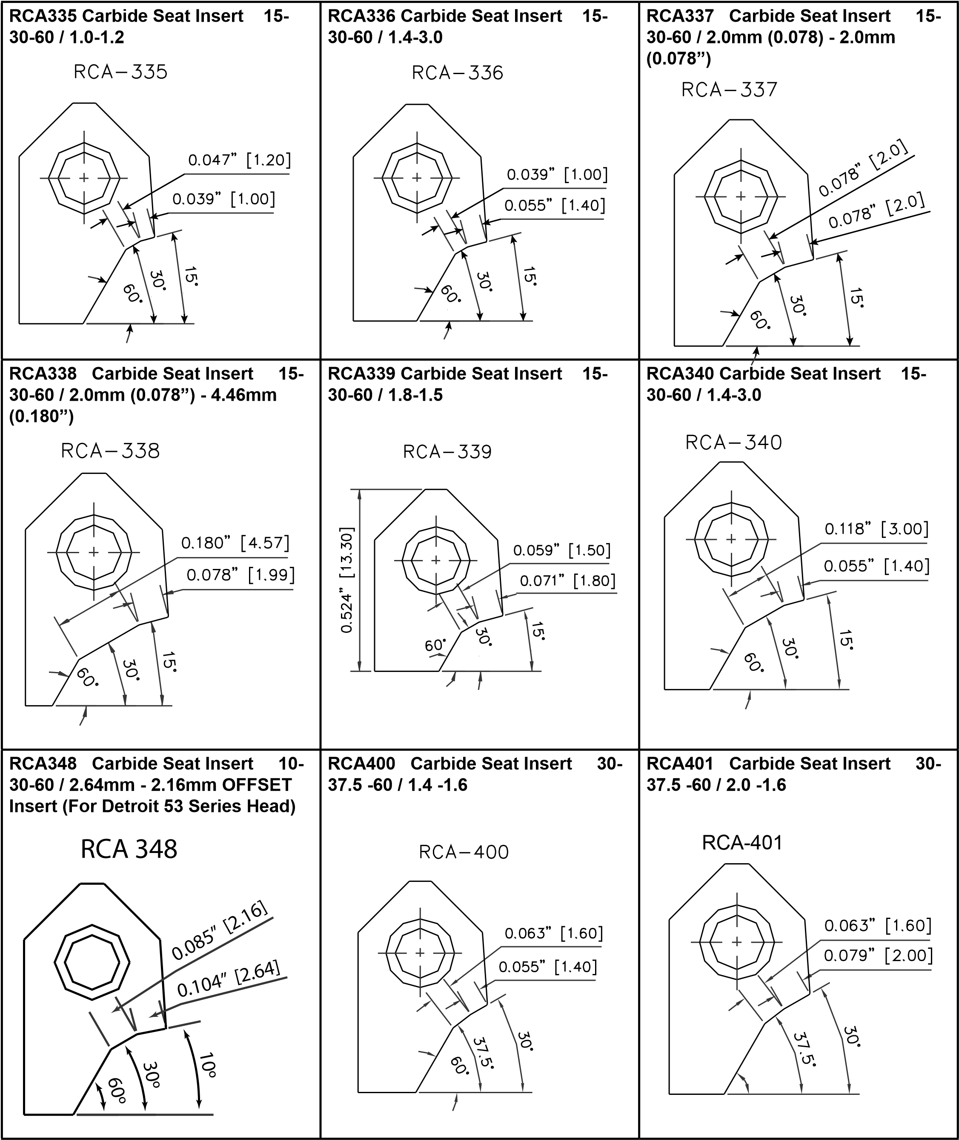

|  |  |  |
| --- | --- | --- |
| RCA402 Carbide Seat Insert 30-  375 -60 / 14 -19 | RCA403 Carbide Seat Insert 30-  375 -60 / 20 -20 | RCA404 Carbide Seat Insert 18-  375 -52 / 06 -21 |
| RCA405 Carbide Seat Insert 15-  375 -60 / 14 -16 | RCA406 Carbide Seat Insert 20-  375 -52 / 12 -18 | RCA407 Carbide Seat Insert 15-  375 -60 / 14 -16 |
| RCA409 Carbide Seat Insert 0-35-  75 / 10-25 | RCA411 Carbide Seat Insert 37 degrees’ / 93mm | RCA418 Carbide Seat Insert 10-  20-60 / 36-305 |
| RCA-409  0.039  ”  [1.0]  0.098  ”  [2.5]  0  º  35  º  75  º | RCA 411  15  º  35  º  60  º  0.067  ”  [1.69]  0.094  ”  [2.4] | RCA 418  10  º  20  º  60  º  0.141  ”  [3.6]  0.138  ”  [3.05] |

|  |  |  |
| --- | --- | --- |
| RCA426 Carbide Seat Insert  5-20-60 / 25-15 | RCA439 Carbide Seat Insert  30-40-60 top, seat width 080 | RCA451 Carbide Seat Insert  R5-35-50-65 / 165-431 |
| RCA 426  R0.020” [R0.5]  20  º  60  º  0.098  ”  [2.5]  0.059  ”  [1.5] | RCA-439  0.080  ”  [2.0]  30  º  40  º  60  º |  |
| RCA500 Carbide Seat Insert 15 degrees / 77mm  RCA 500  15  º  0.303  [7.7]  ” | RCA501 Carbide Seat Insert 20 degrees / 88mm  RCA 501  20  º  0.346  [8.8]  ” | RCA502 Carbide Seat Insert 30 degrees / 90mm |
| RCA503 Carbide Seat Insert 45 degrees / 89mm | RCA504 Carbide Seat Insert 45 degrees 15 ‘ / 80mm | RCA505 Carbide Seat Insert 60 degrees’ / 81mm |
| RCA 503  45  º  0.350  [8.9]  ” |  | RCA 505  60  º  0.319  [8.1]  ” |

|  |  |  |
| --- | --- | --- |
| RCA507 Carbide Seat Insert 75 degrees / 83mm | RCA511 Carbide Seat Insert 94 degrees 08 / 12mm (SHORT PROFILE) | RCA512 Carbide Seat Insert 94 degrees R 08 / 153mm |
| RCA 507  75  º  0.328  ”  [8.3] | RCA 511  4  º  R0.031” [0.8]  0.472  [12.0]  ” |  |
| RCA513 Carbide Seat Insert  94-R05 / 25-65 (OFFSET FOR  COUNTERBORING SMALL SEATS) | RCA521 Carbide Seat Insert 25 degrees’ / 85mm  RCA 521  25  º  0.335  [8.5]  ” | RCA522 Carbide Seat Insert 70 degrees’ / 77mm |
| RCA524 Carbide Seat Insert 82 degrees’ / 707mm | RCA525 Carbide Seat Insert 94 -  60 / 80mm | RCA526 Carbide Seat Insert 45 degree / 984mm |
| RCA 524  82  º  0.278  [7.1]  ” |  | RCA-526  45  º  0.388” [9.84] |

|  |  |  |
| --- | --- | --- |
| RCA527 Carbide Seat Insert 37 degree / 929mm | RCA528 Carbide Seat Insert 35 degree / 95mm | RCA537 Carbide Seat Insert 50 degree / 89mm |
|  | RCA 528  35  º  0.374  ”  [9.5] | RCA 537  50  º  0.350  ”  [8.9] |
| RCA540 Carbide Seat Insert 40 degree  RCA-540 | RCA541 Carbide Seat Insert 10 degree  RCA-541  10  º | RCA547 Carbide Seat Insert 15 degree / 749mm  RCA-547 |
| RCA628 Carbide Seat Insert 30-  R15-15-45-75 / 10-10 | RCB509 Carbide Seat Insert 80 degrees’ / 121mm | RCB510 Carbide Seat Insert 82 degrees’ / 115mm |
| RCA 628  75  º  45  º  15  º  30  º  R0.059” [1.5]  0.039  ”  [1.0]  0.039  ”  [1.0] | 80  º  0.476  [12.1]  ”  RCB-509 |  |

|  |  |  |
| --- | --- | --- |
| RCA511 Carbide Seat Insert 94 degrees 08 / 12mm (SHORT PROFILE)  RCA 511  4  º  R0.031” [0.8]  0.472  [12.0]  ” | RCA512 Carbide Seat Insert 94 degrees R 08 / 153mm | RCA513 Carbide Seat Insert 94-  R05 / 25-65 (OFFSET FOR  COUNTERBORING SMALL SEATS) |
| RCA521 Carbide Seat Insert 25 degrees’ / 85mm  RCA 521  25  º  0.335  [8.5]  ” | RCA522 Carbide Seat Insert 70 degrees’ / 77mm | RCA524 Carbide Seat Insert 82 degrees’ / 707mm  RCA 524  82  º  0.278  [7.1]  ” |
| RCB600 Carbide Seat Insert  R25-38-45-60 / 25-24-100 | RCB601 Carbide Seat Insert R1-  35-45-60-75 / 15-13-10-25 | RCB602 Carbide Seat Insert  R10-35-45-56 / 20-13 |
| RCB 600  60  º  45  º  38  º  R0.098” [2.5]  0.094  ”  [2.4]  0.039  ”  [1.0] | RCB 601  75  º  º  60  º  45  35  º  R0.039” [1.0]  0.051  ”  [1.3]  ”  [1.0]  0.039  0.098  ”  [2.5] | RCB 602  56  º  45  º  35  º  R0.039” [1.0]  0.079  ”  [2.0]  0.051  ”  [1.3] |

|  |  |  |
| --- | --- | --- |
| RCB603 Carbide Seat Insert R12  -45 degrees | RCB604 Carbide Seat Insert R2-  35-45-60-75-82 / 29-13-17-22 | RCB605 Carbide Seat Insert 35-  45-55-65-75 / 25-10-25-25 |
| RCB 603  45  º  R0.472” [12.0]  0.118  ”  [3.0] | RCB 604  82  º  75  º  60  º  45  º  35  º  R0.079” [2.0]  0.114  ”  [2.9]  0.051  ”  [1.3]  0.067  ”  [1.7]  0.087  ”  [2.2] | RCB 605  75  º  65  º  55  º  45  º  º  35  [2.5]  0.098  ”  0.098  [2.5]  ”  0.098  ”  [2.5]  0.039  ”  [1.0] |
| RCB606 Carbide Seat Insert 40R1-45-55-65-75 / 15-13-10-25  RCB 606  75  º  º  65  55  º  45  º  40  º  0.059  ”  [1.5]  0.051  ”  [1.3]  0.039  ”  [1.0]  0.098  ”  [2.5] | RCB607 Carbide Seat Insert  R15-35-45-R12-75-R35 / 19-15-15-  30  RCB 607  75  º  45  º  35  º  R0.138” [3.5]  R0.472” [12.0]  R0.059” [1.5]  ”  [1.9]  0.075  0.059  ”  [1.5] | RCB608 Carbide Seat Insert  R15-35-45-R12-75-R35-45 / 19-15-  10-30  RCB 608  45  º  75  º  45  º  35  º  R0.138” [3.5]  R0.472” [12.0]  R0.059” [1.5]  0.059  ”  [1.5]  0.118  ”  [3.0]  0.039  [1.0]  ” |
| RCB609 Carbide Seat Insert  R15-35-45-R12-75 / 19-15-25-30 | RCB610 Carbide Seat Insert  R15-35-45-R122-85 / 18-15-15-30 | RCA611 Carbide Seat Insert  R15-15-30-45-60-75 / 22-08 |
| RCB 609  75  º  45  º  35  º  R0.472” [12.0]  R0.059” [1.5]  0.075  ”  [1.9]  0.059  ”  [1.5] | RCB 610  85  º  45  º  35  º  R0.472” [12.0]  R0.059” [1.5]  0.059  ”  [1.5]  0.059  ”  [1.5] |  |

|  |  |  |  |
| --- | --- | --- | --- |
| RCA612 Carbide Seat Insert  R12-25-45-65-75 / 12-08 | RCA613 Carbide Seat Insert R2-  30-45-60-R7 / 19-08 | RCA614 Carbide Seat Insert R4  -15 / 552mm | |
|  |  | RCA 614  15  º  0.217  ”  [5.5]  R0.157” [4.0] | |
| RCA615 Carbide Seat Insert R4  -30 / 570mm | RCA616 Carbide Seat Insert R5  -15 / 500mm  RCA 616  15  º  R0.197” [5.0]  0.197  ”  [5.0] | RCA617 Carbide Seat Insert R5  -30 / 600mm  RCA 617  30  º | R0.197” [5.0]  0.236” [6.0] |
| RCA618 Carbide Seat Insert R7  -15 / 44mm | RCA619 Carbide Seat Insert R7  -30 / 44mm | RCB620 Carbide Seat Insert R7  -15 | |
| RCA 618  15  º  R0.276” [7.0]  0.173  ”  [4.4] | RCA 619  30  º  R0.276” [7.0]  0.173  ”  [4.4] | RCB 620  15  º  0.253  [6.4]  ”  R0.276” [7.0] | |

|  |  |  |
| --- | --- | --- |
| RCB621 Carbide Seat Insert 75 -  R7 / 120mm | RCB622 Carbide Seat Insert 80 -  R7 / 900mm | RCA623 Carbide Seat Insert  R08-30-45-60-R13-R15 / 13-10 |
| RCB 621  75  º  R0.276” [7.0] | RCB 622  80  º  R0.276” [7.0] |  |
| RCA624 Carbide Seat Insert R1-  32-45-60 / 13-08  RCA 624  60  º  45  º  32  º  R0.039” [1.0]  0.051  ”  [1.3]  0.031  ”  [0.8] | RCA625 Carbide Seat Insert 30-  R1-32-45-60 / 10-08  RCA 625  60  º  45  º  32  º  30  º  R0.039” [1.0]  0.039  ”  [1.0]  0.031  ”  [0.8] | RCA626 Carbide Seat Insert R15-30-45-60 / 16-10  RCA 626  0.063  ”  [1.6]  0.041  ”  [1.0]  R0.059”  [R1.5]  30  º  45  º  60  º |
| RCA627 Carbide Seat Insert  R15-15-45-75 / 10-10 | RCA628 Carbide Seat Insert 30-  R15-15-45-75 / 10-10 | RCA629 Carbide Seat Insert  R15-38-45-60 / 13-11 |
| RCA 627  75  º  º  45  15  º  R0.059” [1.5]  0.039  ”  [1.0]  0.039  ”  [1.0] | RCA 628  75  º  45  º  15  º  30  º  R0.059” [1.5]  0.039  ”  [1.0]  0.039  ”  [1.0] | RCA 629  60  º  45  º  38  º  R0.059” [1.5]  0.051  ”  [1.3]  0.043  ”  [1.1] |

|  |  |  |
| --- | --- | --- |
| RCA630 Carbide Seat Insert 30-  94-R15-38-45-60 / 13-11 | RCA631 Carbide Seat Insert  R15-30-45-60 / 16-13 | RCA632 Carbide Seat Insert 30-  94-R15-30-45-60 / 16-13 |
| RCA 630  60  º  45  º  38  º  94  º  30  º  R0.059” [1.5]  0.051  ”  [1.3]  0.043  ”  [1.1] | RCA 631  60  º  45  º  30  º  R0.059” [1.5]  0.063  ”  [1.6]  0.051  ”  [1.3] | RCA 632  º  60  45  º  30  º  º  94  º  30  R0.059” [1.5]  0.063  ”  [1.6]  0.051  [1.3]  ” |
| RCA633 Carbide Seat Insert 30-  45-60 / 20 -14 | RCA634 Carbide Seat Insert  R16-30-45-60 / 16-15 | RCA635 Carbide Seat Insert 30-  94-R15-30-45-60 / 16-15 |
| RCA 633  0.078  ”  [2.0]  0.055  ”  [1.4]  30  º  45  º  60  º | RCA 634  60  º  45  º  30  º  R0.063” [1.6]  0.063  ”  [1.6]  0.059  ”  [1.5] | RCA 635  60  º  45  º  30  º  94  º  30  º  R0.059” [1.5]  0.059  [1.5]  ”  0.063  ”  [1.6] |
|  |  |  |

|  |  |  |
| --- | --- | --- |
| RCA636 Carbide Seat Insert  R15-32-45-60 / 16-10-10 (Offset  Bit)  RCA 636  60  º  45  º  32  º  R0.059” [1.5]  0.039  ”  [1.0]  0.039  ”  [1.0] | RCA637 Carbide Seat Insert R15-32-45-60 / 16-10-10  RCA 637  60  º  45  º  32  º  R0.059” [1.5]  0.063  ”  [1.6]  0.039  ”  [1.0] | RCA638 Carbide Seat Insert R15-30-45-75 / 16-10  RCA 638  75  º  45  º  30  º  R0.059” [1.5]  0.063  ”  [1.6]  0.039  ”  [1.0] |
| RCA639 Carbide Seat Insert 30R15-30-45-75 / 10-10  RCA 639  75  º  45  º  30  º  30  º  R0.059” [1.5]  0.039  ”  [1.0]  0.039  ”  [1.0] | RCA640 Carbide Seat Insert R15-32-45-60 / 16-12  RCA 640  60  º  45  º  32  º  R0.059” [1.5]  0.063  ”  [1.6]  0.047  ”  [1.2] | RCA641 Carbide Seat Insert R05-32-45-60 / 15-12  RCA 641  60  º  45  º  32  º  R0.020” [0.5]  0.059  ”  [1.5]  0.047  ”  [1.2] |
| RCA642 Carbide Seat Insert  R15-20-45-60 / 10-10 | RCA643 Carbide Seat Insert 30-  R15-20-45-60 / 10-10 | RCB644 Carbide Seat Insert R3-  30-R13-45-75-R3 / 25-12-12-30 |
| RCA 642  60  º  45  º  20  º  R0.059” [1.5]  0.039  ”  [1.0]  0.039  ”  [1.0] | RCA 643  60  º  45  º  20  º  30  º  R0.059” [1.5]  0.039  ”  [1.0]  0.039  ”  [1.0] | RCB 644  75  º  º  45  30  º  0.047  ”  [1.2]  0.047  ”  [1.2]  R0.118” [R3.0]  TAN 30º-94º  R0.512” [R13.0]  TAN 69º-55º  R0.118” [3.0]  TAN 0º-75º |

|  |  |  |
| --- | --- | --- |
| RCB646 Carbide Seat Insert R2  -35-45-65 / 20-14 - 08 | RCB651 Carbide Seat Insert 30-  94-30-45-60 / 31-15-30 | RCB652 Carbide Seat Insert 30-  94-32-45-60 / 10-08 |
| RCB 646  65  º  45  º  35  º  0.031  ”  [0.8]  0.055  ”  [1.4]  R0.079” [R2.0]  TAN 35º-94º | RCB 651  60  º  45  º  30  º  94  º  º  30  0.059  ”  [1.5]  0.118  ”  [3.0] | RCB 652  60  º  º  45  32  º  30  º  0.039  ”  [1.0]  0.031  ”  [0.8] |
| RCB653 Carbide Seat Insert 30-  45-60 / 12-10  RCB 653  60  º  45  º  30  º  0.039  ”  [1.0]  0.047  ”  [1.2] | RCB654 Carbide Seat Insert 45-  91 / 196-63mm  RCB 654  0.165  ”  [4.2]  0.249  ”  [6.3]  91  º  45  º  0.772  [19.6]  ” | RCA655 Carbide Seat Insert R  500’ / 1600mm  RCA 655  0.63  ”  R5.0  0.630  [16.0]  ” |
| RCA656 Carbide Seat Insert 30-  45-R10 / 15-15  RCA 656  R0.394”  R10.0  30  º  45  º  0.059  ”  [1.5]  0.059  ”  [1.5] | RCA700 Carbide Seat Insert  5-20-60 / 30mm - 25mm (100”) (Cat  3500 series)  RCA 700  60  º  20  º  5  º  0.098  ”  [2.5]  0.118  ”  [3.0] | RCA723 Carbide Seat Insert  5-20-45 / 20mm - 20mm  RCA 723  45  º  20  º  5  º  0.079  ”  [2.0]  0.079  ”  [2.0] |

|  |  |  |
| --- | --- | --- |
| RCA730 Carbide Seat Insert  5-20-45 / 20mm - 32mm (126”) | RCA731 Carbide Seat Insert 11-  20-45 / 18mm - 38mm (150”) | RCA756 Carbide Seat Insert For  CAT C9 Engines |
| RCA 730  45  º  20  º  5  º  0.079  ”  [2.0]  0.126  ”  [3.2] | RCA 731  45  º  20  º  11  º  0.071  ”  [1.8]  0.150  ”  [3.8] | RCA 756  5  º  25  º  60  º  0.055  ”  [1.4]  0.079  ”  [2.0] |
| RCA764 Carbide Seat Insert 15-  40-60 top, seat width 127-165 | RCA818 Carbide Seat Insert 15-  25-70 with 70 degree radius top, - 15-30 | RCA819 Carbide Seat Insert 15-  40-70 with 70 degree radius top, - 10-25 |
|  | RCA-818  [3.3]  0.129  ”  70  º  º  25  15  º  70  º  ”  [1.0]  0.039  [1.5]  ”  0.059  ”  [3.0]  0.118 | RCA-819  [4.6]  0.182  ”  º  70  º  40  º  15  70  º  0.039  ”  [1.0]  ”  0.039  [1.0]  ”  [2.5]  0.098 |

## RCC Profiles

|  |  |  |
| --- | --- | --- |
| RCC702 Carbide Seat Insert 20º | RCC703 Carbide Seat Insert 30º | RCC704 Carbide Seat Insert 45º |
| 20  º  0.386  [9.8]  ”  RCC-702 | 30  º  0.413” [10.5]  RCC-703 | 45  º  0.402” [10.2]  RCC-704 |
| RCC705 Carbide Seat Insert 94º R  08 / 18MM  94  º  R0.8  0.432” [11.0]  RCC-705 | RCC721 C Blank Carbide Seat  Insert 0-20-60 / 18-20  0.079  ”  [2.0]  0.071  ”  [1.8]  20  º  60  º  RCC-721 | RCC722 C Blank Carbide Seat  Insert 0-20-75 / 20-20  0.079  ”  [2.0]  0.079  ”  [2.0]  20  º  75  º  RCC-722 |
| RCC723 C Blank Carbide Seat  Insert 5-20-45 / 20-20 | RCC724 C Blank Carbide Seat  Insert 10-20-75 / 20-23 | RCC725 C Blank Carbide Seat  Insert 0-20-60 / 18-25 |
| 0.079  ”  [2.0]  0.079  ”  [2.0]  5  º  20  º  45  º  RCC-723 | 0.091  ”  [2.3]  0.079  ”  [2.0]  10  º  20  º  75  º  RCC-724 | 0.098  ”  [2.5]  0.071  ”  [1.8]  20  º  60  º  RCC-725 |

|  |  |  |
| --- | --- | --- |
| RCC726 C Blank Carbide Seat  Insert 5-20-75 / 20-25 | RCC727 C Blank Carbide Seat  Insert 15-2025-60 / 30-25 | RCC728 C Blank Carbide Seat  Insert 15-20-60 / 28-266 |
| 0.098  ”  [2.5]  0.079  ”  [2.0]  5  º  20  º  75  º  RCC-726 | 0.098  ”  [2.5]  0.118  ”  [3.0]  15  º  20.25  º  60  º  RCC-727 | 0.105  ”  [2.7]  0.110  ”  [2.8]  15  º  20  º  60  º  RCC-728 |
| RCC729 C Blank Carbide Seat  Insert 5-20-45 / 30-30  0.118  ”  [3.0]  0.118  ”  [3.0]  5  º  20  º  45  º  RCC-729 | RCC730 C Blank Carbide Seat  Insert 5-20-45 / 20-32  0.126  ”  [3.2]  0.079  ”  [2.0]  5  º  20  º  45  º  RCC-730 | RCC731 C Blank Carbide Seat  Insert 11-20-45 / 18-38  0.150  ”  [3.8]  0.071  ”  [1.8]  11  º  20  º  45  º  RCC-731 |
| RCC741 C Blank Carbide Seat  Insert T15 Locking screw 15-30-60 / 20-46 | RCC742 C Blank Carbide Seat  Insert 15-30-45 / 20-18 | RCC743 C Blank Carbide Seat  Insert 15-30-15 / 20-22 |
|  | 0.071  ”  [1.8]  0.079  ”  [2.0]  15  º  30  º  45  º  RCC-742 | 0.087  ”  [2.2]  0.079  ”  [2.0]  15  º  30  º  60  º  RCC-743 |

|  |  |  |
| --- | --- | --- |
| RCC761 C Blank Carbide Seat  Insert 30-45-60 / 16-19 | RCC762 C Blank Carbide Seat  Insert 30-45-60 / 20-25 | RCC763 C Blank Carbide Seat  Insert 30-45-60 / 22-20 |
| 0.075  ”  [1.9]  0.063  ”  [1.6]  30  º  45  º  60  º  RCC-761 | 0.098”[2.5]  0.079  ”  [2.0]  30  º  45  º  60  º  RCC-762 | 0.079  ”  [2.0]  0.087  ”  [2.2]  30  º  45  º  60  º  RCC-763 |
| RCC765 C Blank Carbide Seat  Insert 13-3018-60/20-38  0.150  ”  [3.8]  0.080  ”  [2.0]  15  º  30  º18’  60  º  RCC-765 |  |  |

## SG Insert Cross Reference Chart

|  |  |  |  |  |  |  |  |  |  |  |  |  |  |  |  |  |  |  |  |  |  |  |  |  |  |  |  |
| --- | --- | --- | --- | --- | --- | --- | --- | --- | --- | --- | --- | --- | --- | --- | --- | --- | --- | --- | --- | --- | --- | --- | --- | --- | --- | --- | --- |
| Regis  # | R-  11 |  |  |  | R-  26 | R-  8 | R-  6 |  | R-  34 |  |  |  |  |  |  |  |  |  |  |  | R-  29 |  |  |  |  |  |  |
| Top-seat widt  h | 1.  2    -  1.  0 | 2.  0    -  1.  0 | 1.  2    -  1.  3 | 1.  6    -  1.  3 | 2.  0    -  1.  3 | 2.  0    -  1.  3 | 1.  8    -  1.  5 | 1.  8    -  1.  5 | 1.  8    -  1.  5 | 2.  0    -  1.  5 | 3.  0    -  1.  5 | 1.  2    -  1.  6 | 1.  2    -  1.  6 | 1.  4    -  1.  6 | 1.  6    -  1.  6 | 1.  6    -  1.  6 | 1.  6-  1.  6 | 1.  8    -  1.  6 | 2.  0    -  1.  6 | 2.  0    -  1.  6 | 2.  0    -  1.  6 | 3.  0    -  1.  6 | 3.  0    -  1.  8 | 1.  2    -  1.  9 | 1.  2    -  1.  9 | 1.  6    -  1.  9 | 1.  8    -  1.  9 |
| Top-  Se  at-Thr  oat An  gl  e | 30-  45  -6  0 | 30-  45  -6  0 | 30-  45  -6  0 | 30-  45  -6  0 | 37-  45  -5  2 | 30-  45  -5  2 | 37-  45  -5  2 | 15-  45  -6  0 | 30-  45  -5  2 | 30-  45  -6  0 | 30-  45  -6  0 | 30-  45  -5  2 | 30-  45  -6  0 | 30-  45  -6  0 | 15-  45  -6  0 | 30-  45  -5  2 | 30-  45  -6  0 | 30-  45  -5  2 | 15-  45  -6  0 | 30-  45  -5  2 | 30-  45  -6  0 | 30-  45  -6  0 | 30-  45  -6  0 | 30-  45  -5  2 | 30-  45  -6  0 | 30-  45  -6  0 | 30-  45  -5  2 |
| R-  1    ref of | A/  B st  yle    ti  ps |  |  |  |  |  |  |  |  |  |  |  |  |  |  |  |  |  |  |  |  |  |  |  |  |  |  |
| Se  rd  i-  ital  y |  |  |  |  |  |  |  |  |  |  |  |  |  |  |  |  |  |  |  |  |  |  |  |  |  |  |  |
| Other Re  f  # |  |  |  |  |  |  |  |  |  |  |  |  |  |  |  |  |  |  |  |  |  |  |  |  |  |  |  |
| Sunn  en  # | A  05  42  4 | A -0  90  40 | A  08  22  4 | A  09  93  2 | A  05  94  0 | A  06  04  0 | A  06  33  6 | A  05  33  6 | A  07  03  6 | A  07  84  0 |  | A  07  52  4 | A  07  62  4 | A  09  72  8 | A  10  03  2 | A  10  13  2 | A  09  43  2 | A  09  63  6 |  | A  08  74  0 | A  06  64  0 | A  08  66  0 | A  10  26  0 | A  08  92  4 | A  09  12  4 | A  09  33  2 | A  07  73  6 |
| Serd  i  ol  d  # | 10  F  45  x  60  -  A  1 | 10  K  45  X60-A1 | 13  F  45  X  60  -  A  1 | 13  H  45  X60-A1 | 13  K  45  G52-A1 | 13  K  45  X52-A1 | 15  J  45  G52-A1 | 15  J  45  U6  0-  A1 | 15  J  45  X5  2-  A1 | 15  K  45  X60-A1 | 15  Q  45  X60-A1 | 16  F  45  X  52  -  A  1 | 16  F  45  X  60  -  A  1 | 16  G  45  X  60  -  A  1 | 16  H  45  U6  0-  A1 | 16  H  45  X52-A1 | 16  H  45  X60-A1 | 16  J  45  X5  2-  A1 | 16  K  45  U6  0-  1  A | 16  K  45  X52-A1 | 16  K  45  X60-A1 | 16  Q  45  X60-A1 | 18  Q  45  X60-A1 | 19  F  45  X  52  -  A  1 | 19  F  45  X  60  -  A  1 | 19  H  45  X60-A1 | 19  J  45  X5  2-  A1 |
| Goods  on | FT  -4  50  39  V1 | FT  -4  50  59  V3 | FT  -4  50  51  V4 |  | FT  -4  50  51  X1 | FT  -4  50  51  V3 | FT  -4  50  59  X1 |  |  |  |  |  | FT  -4  50  63  V3 |  |  |  |  | FT  -4  50  63  W1 |  |  | FT  -4  50  63  V2 |  |  |  |  |  |  |
| K-line | KL-9  40  1-  11 |  |  |  | KL-9  40  1-  28 | KL-9  40  1-  08 | KL-9  40  1-  06 |  |  |  |  |  |  | KL-9  40  1-  34 |  |  |  |  |  |  | KL-9  40  1-  36 |  |  | KL-9  40  1-  37 |  |  | KL-9  40  1-  30 |
| Ne  we  n  # | A1  -4  02  8 | A1  -4  30  3 | A1  -4  22  1 | A1  -4  48  0 | A1  -4  03  3 | A1  -4  03  4 | A1  -4  03  7 | A1  -4  02  5 | A1  -4  07  7 | A1  -4  17  7 | A1  -4  98  6 | A1  -4  13  5 | A1  -4  13  6 | A1  -4  39  1 | A1  -4  48  1 | A1  -4  48  2 |  | A1  -4  36  1 | A1  -4  11  7 | A1  -4  26  6 | A1  -4  04  0 | A1  -4  25  8 | A1  -4  48  3 | A1  -4  29  9 | A1  -4  30  6 | A1  -4  33  9 | A1  -4  14  6 |
| Rottler  # | RCA  00  1 | RCA  00  2 | RCA  00  3 | RCA  00  4 | RCA  00  5 | RCA  00  6 | RCA  00  7 | RCA  00  8 | RCA  00  9 | RCA  01  0 | RCA  01  1 | RCA  01  2 | RCA  01  3 | RCA  01  4 | RCA  01  5 | RCA  01  6 | RCA  01  7 | RCA  01  8 | RCA  01  9 | RCA  02  0 | RCA  02  1 | RCA  02  2 | RCA  02  3 | RCA  02  4 | RCA  02  5 | RCA  02  6 | RCA  02  7 |

|  |  |  |  |  |  |  |  |  |  |  |  |  |  |  |  |  |  |  |  |  |  |  |  |  |  |  |  |  |
| --- | --- | --- | --- | --- | --- | --- | --- | --- | --- | --- | --- | --- | --- | --- | --- | --- | --- | --- | --- | --- | --- | --- | --- | --- | --- | --- | --- | --- |
| Regis  # |  | R-  15 |  |  |  |  |  |  |  | R-  23 | R-  10 | R-  9 | R-  27 | R-  3 | R-  13 | R-  1 |  |  |  | R-  12 |  | R-  14 |  |  |  |  |  |  |
| Top-seat widt  h | 2.  0    -  1.  9 | 2.  0    -  1.  9 | 1.  6    -  2.  0 | 1.  6    -  2.  0 | 1.  4    -  2.  2 | 2.  0    -  2.  3 | 2.  0    -  2.  5 | 1.  4    -  1.  0 | 1.  8    -  1.  0 | 1.  6    -  1.  0 | 1.  6    -  1.  0 | 1.  6    -  1.  0 | 2.  0    -  1.  3 | 1.  0    -  1.  3 | 1.  0    -  1.  4 | 1.  8    -  1.  5 | 1.  4    -  1.  5 | 1.  4    -  1.  6 | 1.  8    -  1.  6 | 1.  0    -  1.  6 | 2.  0-  1.  7 | 1.  6    -  1.  8 | 0.  8    -  1.  9 | 1.  4    -  2.  0 | 1.  8    -  2.  0 | 1.  2    -  2.  0 | 1.  4    -  2.  5 | 1.  8  -2  .5 |
| Top-  Se  at-Thr  oat An  gl  e | 30-  45  -5  2 | 30-  45  -6  0 | 30-  45  -7  0 | 30-  45  -7  5 | 30-  45  -6  0 | 30-  45  -6  0 | 30-  45  -6  0 | 25-  45  -6  0 | 25  -4  5  -6  0 | 35-  45  -5  2 | 35-  45  -5  5 | 35-  45  -6  0 | 30-  45  -6  0 | 30-  45  -6  0 | 30-  45  -6  0 | 30-  45  -6  0 | 30-  45  -6  0 | 25-  45  -6  0 | 25-  45  -6  0 | 30-  45  -6  0 | 30-  45  -6  0 | 30-  45  -6  0 | 30-  45  -5  2 | 25-  45  -6  0 | 25-  45  -6  0 | 30-  45  -6  0 | 25-  45  -6  0 | 25-  45  -6  0 |
| R-  1    ref of |  |  |  |  |  |  |  |  |  |  |  |  |  |  |  |  |  |  |  |  |  |  |  |  |  |  |  |  |
| Se  rd  i-  ital  y |  |  |  |  |  |  |  |  |  |  |  |  |  |  |  |  |  |  |  |  |  |  |  | 42  03    A1 |  |  |  |  |
| Other Re  f  # |  |  |  |  |  |  |  | 41  0  A  1  (    136  5) |  |  |  |  |  |  |  |  |  |  |  |  |  |  |  | 42  0  A  1  (    15  88) |  |  |  |  |
| Sunn  en  # | A  10  34  0 | A  06  84  0 | A  08  33  2 | A  10  43  2 | A  10  51  2 | A  09  23  6 | A  10  64  0 | A  04  32  8 | A  04  43  6 | A  05  53  2 | A  05  63  2 | A  05  73  2 | A  06  14  0 | A  05  82  0 | A  06  22  0 | A  06  43  6 | A  08  12  8 | A  04  72  8 | A  04  83  6 | A  06  52  0 |  | A  06  73  2 |  | A  04  92  8 |  | A  06  92  4 | A  05  02  8 |  |
| Serd  i  ol  d  # | 19  K  45  X52-A1 | 19  K  45  X60-A1 | 20  H  45  X70-A1 | 20  H  45  X75-A1 | 22  G  45  X  60  -  A  1 | 23  K  45  X60-A1 | 25  K  45  X60-A1 | 10  G  45  V  60  -  A1 | 10  J  45  V6  0-  A1 | 10  H  45  F52-A1 | 10  H  45  F55-A1 | 10  H  45  F60-A1 | 13  K  45  X60-A1 | 13  E4  5  X  60  -  A1 | 14  E4  5  X  60  -  A1 | 15  J  45  X6  0-  A1 | 15  G  45  X  60  -  A  1 | 16  G  45  V  60  -  A1 | 16  J  45  V6  0-  A1 | 16  E4  5  X  60  -  A1 | 17  K  45  X60-A1 | 18  H  45  X60-A1 | 19  D  45  X  52  -  A1 | 20  G  45  V  60  -  A1 | 20  J  45  V6  0-  A1 | 20  F  45  X  60 | 25  G  45  V  60  -  A1 | 25  J  45  V6  0-  A1 |
| Goods  on |  | FT  -4  50  75  V1 |  |  |  |  |  | FT  -4  50  39  U1 | FT  -4  50  39  U2 | FT  -4  50  39  W1 | FT  -4  50  39  W2 | FT  -4  50  39  W3 | FT  -4  50  51  V1 | FT  -4  50  51  V2 | FT  -4  50  55  V1 | FT  -4  50  59  V1 | FT  -4  50  59  V2 | FT  -4  50  63  U1 | FT  -4  50  63  U2 | FT  -4  50  63  V1 | FT  -4  50  67  V1 | FT  -4  50  71  V1 | FT  -4  50  75  V2 | FT  -4  50  79  U1 | FT  -4  50  79  U2 | FT  -4  50  79  V1 | FT  -4  50  98  U1 | FT  -4  50  98  U2 |
| K-line |  | KL-9  40  1-  15 |  |  |  |  |  | KL-9  40  1-  32 | KL-9  40  1-  33 | KL-9  40  1-  23 | KL-9  40  1-  10 | KL-9  40  1-  09 | KL-9  40  1-  54 | KL-9  40  1-  03 | KL-9  40  1-  13 | KL-9  40  1-  01 |  |  | KL-9  40  1-  35 | KL-9  40  1-  12 |  | KL-9  40  1-  14 |  | KL-9  40  1-  38 | KL-9  40  1-  52 | KL-9  40  1-  07 | KL-9  40  1-  39 | KL-9  40  1-  53 |
| Ne  we  n  # | A1  -4  48  4 | A1  -4  04  2 | A1  -4  23  6 | A1  -4  48  5 |  | A1  -4  34  8 | A1  -4  48  7 | A1  -1  10  2 | A1  -1  10  3 | A1  -4  02  9 | A1  -4  03  0 | A1  -4  03  1 | A1  -4  03  5 | A1  -4  03  2 | A1  -4  03  6 | A1  -4  03  8 | A1  -4  21  6 | A1  -1  16  2 | A1  -1  16  3 | A1  -4  03  9 |  | A1  -4  04  1 | A1  -4  14  5 | A1  -1  20  2 | A1  -1  20  3 | A1  -4  04  3 | A1  -1  25  2 | A1  -1  25  3 |
| Rottler  # | RCA  02  8 | RCA  02  9 | RCA  03  0 | RCA  03  1 | RCA  03  2 | RCA  03  3 | RCA  03  4 | RCA  03  5 | RCA  03  6 | RCA  03  7 | RCA  03  8 | RCA  03  9 | RCA  04  0 | RCA  04  1 | RCA  04  2 | RCA  04  3 | RCA  04  4 | RCA  04  5 | RCA  04  6 | RCA  04  7 | RCA  04  8 | RCA  04  9 | RCA  05  0 | RCA  05  1 | RCA  05  2 | RCA  05  3 | RCA  05  4 | RCA  05  5 |

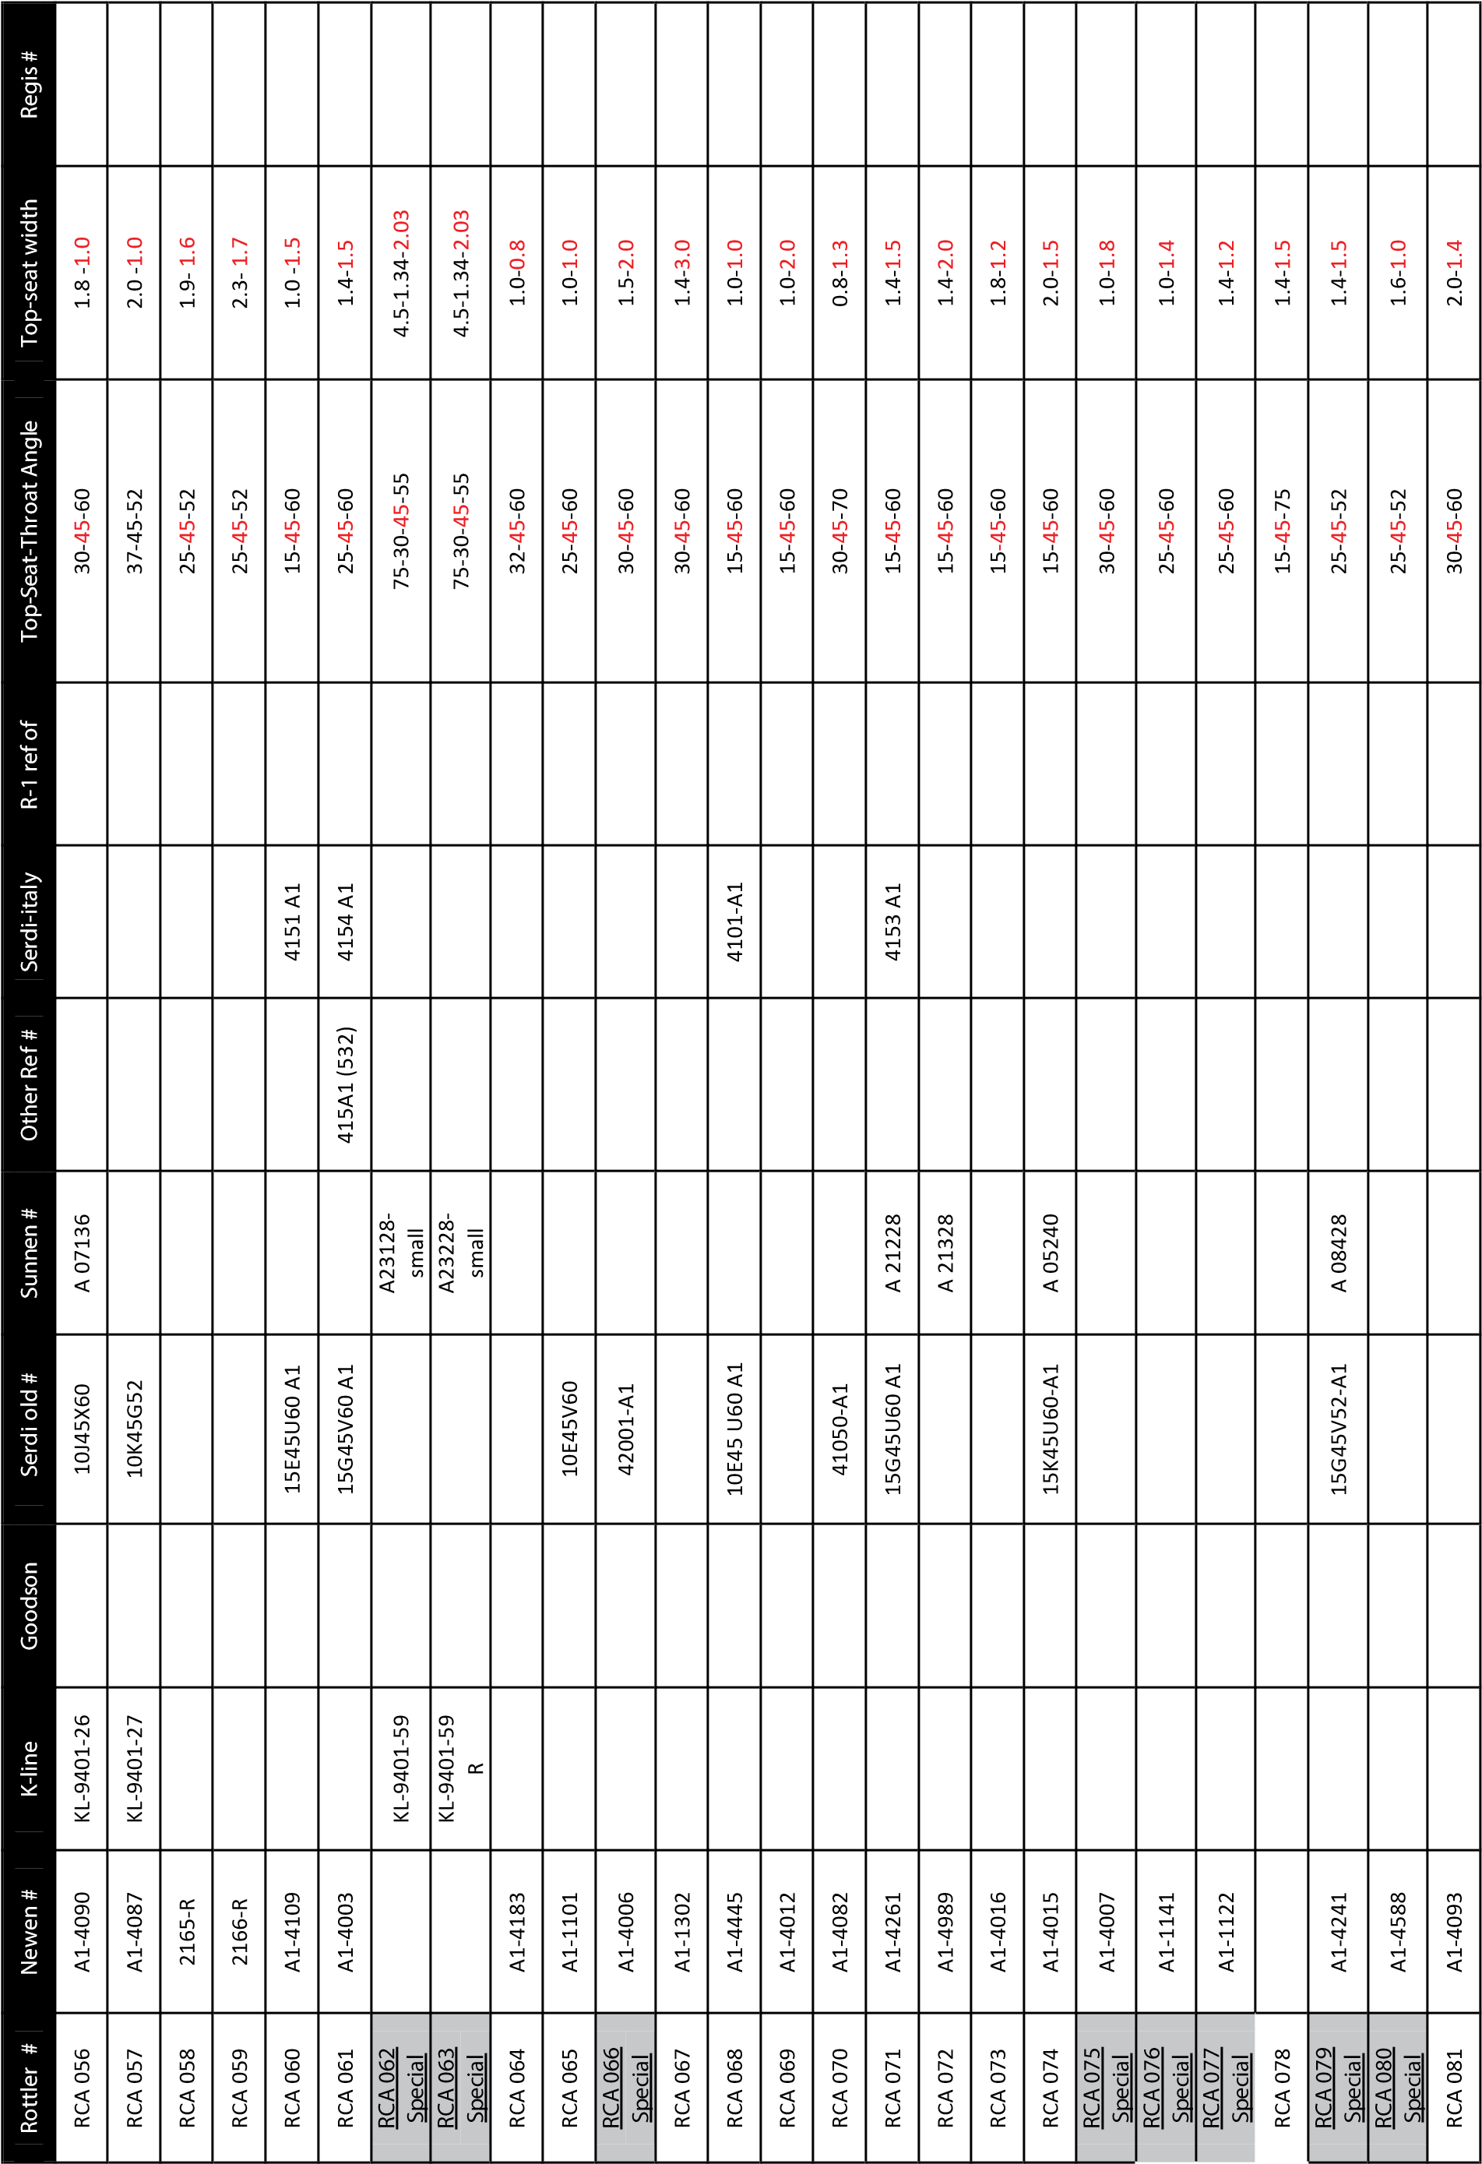

|  |  |  |  |  |  |  |  |  |  |  |  |  |  |  |  |  |  |  |  |  |  |  |  |  |  |  |  |  |
| --- | --- | --- | --- | --- | --- | --- | --- | --- | --- | --- | --- | --- | --- | --- | --- | --- | --- | --- | --- | --- | --- | --- | --- | --- | --- | --- | --- | --- |
| Regis  # |  |  |  | R-  2 |  |  |  |  |  |  |  |  | R-  28 |  |  |  | R-  30 | R-  17 |  |  |  |  | R-  19 | R-  21 |  |  | R-  20 | R-  22 |
| Top-seat widt  h | 0.  6  -2  .2 | 2.  0  -2  .2 |  | 1.  0-  1.  3 | 2.  0-  1.  3 | 2.  0-  1.  3 | 1.  4-  1.  5 | 1.  8-  1.  5 | 2.  0-  1.  5 | 1.  2-  1.  6 | 1.  8-  1.  6 | 1.  8-  1.  6 | 2.  0-  1.  6 | 2.  0-  1.  6 | 2.  2-  1.  6 | 2.  0-  1.  8 | 1.  0-  1.  9 | 2.  0-  1.  9 | 1.  2-  2.  0 | 2.  0-  2.  0 | 2.  0-  2.  2 | 3.  0-  3.  8 | 1.  6-  1.  0 | 2.  0-  1.  5 | 1.  8-  1.  5 | 2.  2-  1.  5 | 3.  0-  1.  5 | 1.  4-  2.  0 |
| Top-  Se  at-Thr  oat An  gl  e | 30-  45  -6  0 | 30-  45  -6  0 |  | 15-  30  -4  5 | 15-  30  -4  5 | 15-  30  -6  0 | 15-  30  -4  5 | 15-  30  -4  5 | 15-  30  -6  0 | 15-  30  -4  5 | 15-  30  -4  5 | 15-  30  -5  2 | 15-  30  -4  5 | 15-  30  -6  0 | 15-  30  -6  0 | 15-  30  -4  5 | 15-  30  -4  5 | 15-  30  -6  0 | 15-  30  -4  5 | 15-  30  -4  5 | 15-  30  -6  0 | 20-  30  -4  5 | 20-  30  -5  2 | 0-  30  -60 | 15-  30  -6  0 | 15-  30  -6  0 | 20-  30  -6  0 | 15-  30  -6  0 |
| R-  1    ref of |  |  |  |  |  |  |  |  |  |  |  |  |  |  |  |  |  |  |  |  |  |  |  |  |  |  |  |  |
| Se  rd  i-  ital  y |  |  |  |  |  |  |  |  |  |  |  |  |  |  |  |  |  |  |  |  |  |  |  |  |  |  |  | 32  01    A1 |
| Other Re  f  # |  |  |  |  |  |  |  |  |  |  |  |  |  |  |  |  |  |  |  |  |  |  |  |  |  |  |  |  |
| Sunn  en  # |  |  |  | A  00  82  0 | A  01  54  0 | A  01  24  0 | A  01  72  8 | A  01  43  6 | A  02  74  0 | A  01  92  4 | A  02  23  6 | A  02  33  6 | A  00  94  0 | A  01  64  0 |  | A  02  14  0 | A  01  82  0 | A  01  14  0 | A  02  42  4 | A  02  04  0 | A  02  54  0 | A  02  66  0 | A  01  33  2 |  | A  00  23  6 |  |  | A  00  32  8 |
| Serd  i  ol  d  # |  |  |  | 13  E3  0  U  45  -  A  1 | 13  K  30  U4  5-  1  A | 13  K  30  U6  0-  1  A | 15  G  30  U4  5-  1  A | 15  J  30  U4  5-  A1 | 15  K  30  U6  0-  1  A | 16  F  30  U4  5-  A1 | 16  J  30  U4  5-  A1 | 16  J  30  U5  2-  A1 | 16  K  30  U4  5-  1  A | 16  K  30  U6  0-  1  A | 16  L3  0  U  60  -  A  1 | 18  K  30  U4  5-  1  A | 19  E3  0  U  45  -  A  1 | 19  K  30  U6  0-  1  A | 20  F  30  U4  5-  A1 | 20  K  30  U4  5-  1  A | 22  K  30  U6  0-  1  A | 38  Q  30  D45-A1 | 10  H  30  D52-A1 | 15  K  30  R6  0-  A1 | 15  J  30  U6  0-  A1 | 15  L3  0  U  60  -  A  1 | 15  Q  30  D60-A1 | 20  G  30  U6  0 |
| Goods  on |  |  |  | FT  -3  00  51  S1 |  |  |  |  | FT  -3  00  59  S3 |  |  |  | FT  -3  00  63  S1 |  |  |  | FT  -3  00  75  S1 | FT  -3  00  75  S2 |  |  |  |  | FT  -3  00  39  T1 | FT  -3  00  59  P1 | FT  -3  00  59  S1 | FT  -3  00  59  S2 | FT  -3  00  59  T1 | FT  -3  00  79  S1 |
| K-line |  |  |  | KL-9  40  1-  02 |  |  |  |  | KL-9  40  1-  41 |  |  |  | KL-9  40  1-  42 |  |  |  | KL-9  40  1-  43 | KL-9  40  1-  17 |  |  |  |  | KL-9  40  1-  19 | KL-9  40  1-  21 | KL-9  40  1-  40 |  | KL-9  40  1-  20 | KL-9  40  1-  22 |
| Ne  we  n  # | A1  -4  48  6 | A1  -4  34  3 |  | A1  -3  02  3 | A1  -3  06  5 | A1  -3  06  1 | A1  -3  06  8 | A1  -3  06  4 | A1  -3  20  0 | A1  -3  07  8 | A1  -3  19  4 | A1  -3  19  5 | A1  -3  02  6 | A1  -3  06  7 | A1  -4  99  7 | A1  -3  14  6 | A1  -3  07  2 | A1  -3  02  9 | A1  -3  19  6 | A1  -3  08  4 | A1  -3  19  8 | A1  -3  19  9 | A1  -3  06  2 | A1  -3  02  4 | A1  -2  15  3 |  | A1  -3  02  5 | A1  -2  20  2 |
| Rottler  # | RCA  08  2 | RCA  08  3 | RCA  17  1 | RCA  30  0 | RCA  30  1 | RCA  30  2 | RCA  30  3 | RCA  30  4 | RCA  30  5 | RCA  30  6 | RCA  30  7 | RCA  30  8 | RCA  30  9 | RCA  31  0 | RCA  31  1 | RCA  31  2 | RCA  31  3 | RCA  31  4 | RCA  31  5 | RCA  31  6 | RCA  31  7 | RCA  31  8 | RCA  32  1 | RCA  32  2 | RCA  32  3 | RCA  32  4 | RCA  32  5 | RCA  32  6 |

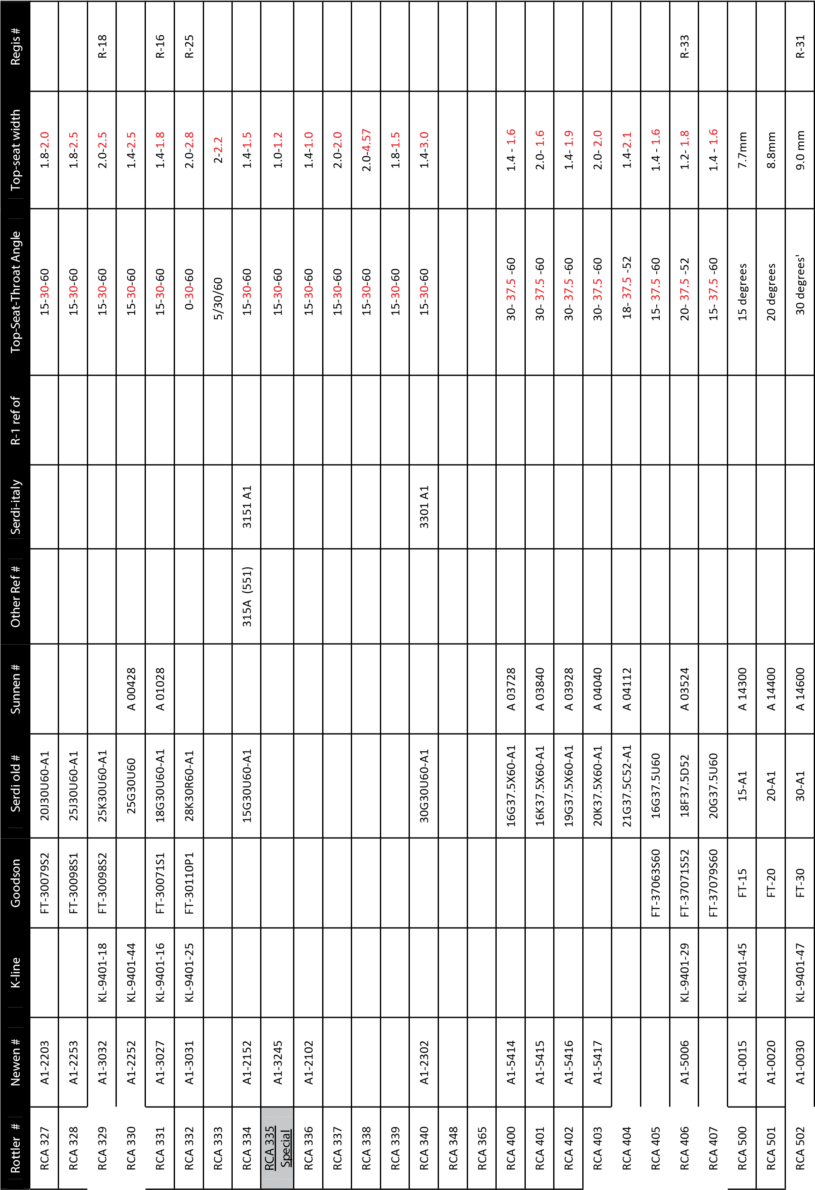

|  |  |  |  |  |  |  |  |  |  |  |  |  |  |  |  |  |  |  |  |  |  |  |  |  |  |  |  |
| --- | --- | --- | --- | --- | --- | --- | --- | --- | --- | --- | --- | --- | --- | --- | --- | --- | --- | --- | --- | --- | --- | --- | --- | --- | --- | --- | --- |
| Regis  # | R-  32 |  |  |  |  | R-  24 |  |  |  |  |  |  |  |  |  |  |  |  |  |  |  |  |  |  |  |  |  |
| Top-seat widt  h | 8.  9    mm | 8.  0    mm | 8.  1    mm | 8.  3  m  m | 12    mm | 15.  3    mm | 2.  5-6.  5 | 8.  5    mm | 7.  7    mm | 7.  07  mm |  | 11.  97  m  m | 9.  3    mm | 2.  2-  0.  8 | 1.  2-  0.  8 | 1.  9-  0.  8 | 5.  52    mm | 5.  70  mm | 5.  00  mm | 6.  00  mm | 4.  4    mm | 4.  4    mm | 1.  3-  1.  0 | 1.  3-  0.  8 | 0.  7-  0.  8 | 1.  6-  1.  0 | 1.  0-  1.  0 |
| Top-  Se  at-Thr  oat An  gl  e | 45    de  gr  ees' | 45    deg  15    ' | 60    de  gr  ees' | 75    de  gr  ee  s | 94    deg-  R  0.  8 | 94    deg-  R  0.  8 | 94-  R0  .5 | 25    de  gr  ees' | 70    de  gr  ees' | 82    de  gr  ees' | 94-  CHA  ME  R 60  DEGR  EE | 45    DE  GR  EES | 37    de  gr  ees' | R1  .5  -1  5-  30  -  45  -60-75 | R1  .2  -2  5-  45  -65-75 | R2  -30-  45  -  60  -  R7 | R4 -  15 | R4 -  30 | R5 -  15 | R5 -  30 | R7 -  15 | R7 -  30 | R0  .8  -3  0-  45  -6  0-  R1  3-  1  R  .5 | R1  -32-  45  -6  0 | 30-  R1  .5  -3  2-  45  -60 | R1  .5  -3  0-  45  -6  0 | R1  .5  -1  5-  45  -7  5 |
| R-  1    ref of |  |  |  |  |  |  |  |  |  |  |  |  |  |  |  |  |  |  |  |  |  |  |  |  |  |  |  |
| Se  rd  i-  ital  y |  |  |  |  |  |  |  |  |  |  |  |  |  |  |  |  |  |  |  |  |  |  |  |  |  |  |  |
| Other Re  f  # |  |  |  |  |  |  |  |  |  |  |  |  |  |  |  |  |  |  |  |  |  |  |  |  |  |  |  |
| Sunn  en  # | A  14  90  0 |  | A  15  00  0 | A  15  20  0 |  |  |  | A  14  50  0 | A  15  10  0 | A  15  40  0 |  |  | A  14  80  0 |  |  |  | A  13  30  0 | A  13  40  0 | A  13  50  0 | A  13  20  0 | A  13  60  0 | A  13  70  0 |  | A  10  72  6 | A  16  19  6 | A  11  03  2 | A  12  24  0 |
| Serd  i  ol  d  # | 45-  A1 | 45.  15  -  A1 | 60-  A1 | 75-  A1 | L-  11 | L-  12 | L-  12  -offset | 25-  A1 |  | 82-  A1 |  |  | 37-  A1 | HP1126-A1 | HP1179-A1 | HP1118-A1 | R4  -15-A1 | R4  -30-A1 | R5  -15-A1 | R5  -30-A1 | R7  -15-A1 | R7  -30-A1 | HP1096-A1 | 40  80  5    -  A1 | 40  80  5-  A2 | 41  00  1-  A1 | 41  00  3-  A1 |
| Goods  on | F  T-45 |  | FT  -6  0 | FT  -7  5 |  | FT  -9  0 |  | FT  -2  5 | FT  -7  0 | FT  -8  2 |  |  | FT  -3  7 |  |  |  | FT  -5  121  A  -  H  P |  |  |  |  |  | FT  -5  118  A  -  H  P |  |  | FT  -5  043  A  -  HD |  |
| K-line | KL-9  40  1-  48 |  | KL-9  40  1-  49 | KL-9  40  1-  50 |  | KL-9  40  1-  24 |  | KL-9  40  1-  46 | KL-9  40  1-  04 | KL-9  40  1-  51 |  |  |  |  |  |  |  |  |  |  |  |  |  |  |  |  |  |
| Ne  we  n  # | A1  -0  04  5 | A1  -4  88  8 | A1  -0  06  0 | A1  -0  07  5 | A1  -90-  12 | A1  -90-  16 |  | A1  -0  02  5 | A1  -0  07  0 | A1  -0  08  2 | A1  -91-  16 |  | A1  -0  03  7 | A1  -5  07  4 | A1  -5  44  7 | A1  -5  07  3 | A1  -5  12  1 | A1  -5  16  8 | A1  -5  42  8 | A1  -5  07  9 | A1  -5  42  9 | A1  -5  43  0 | A1  -5  11  8 | A1  -4  49  6 | A2  -4  49  6 | A1  -5  04  3 | A1  -5  44  8 |
| Rottler  # | RCA  50  3 | RCA  50  4 | RCA  50  5 | RCA  50  7 | RCA  51  1 | RCA  51  2 | RCA  51  3 | RCA  52  1 | RCA  52  2 | RCA  52  4 | RCA  52  5 | RCA  52  6 | RCA  52  7 | RCA  61  1 | RCA  61  2 | RCA  61  3 | RCA  61  4 | RCA  61  5 | RCA  61  6 | RCA  61  7 | RCA  61  8 | RCA  61  9 | RCA  62  3 | RCA  62  4 | RCA  62  5 | RCA  62  6 | RCA  62  7 |

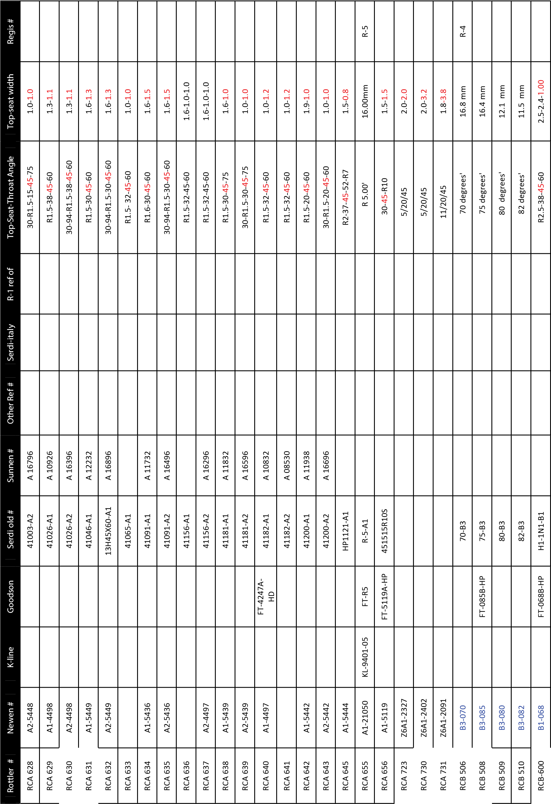

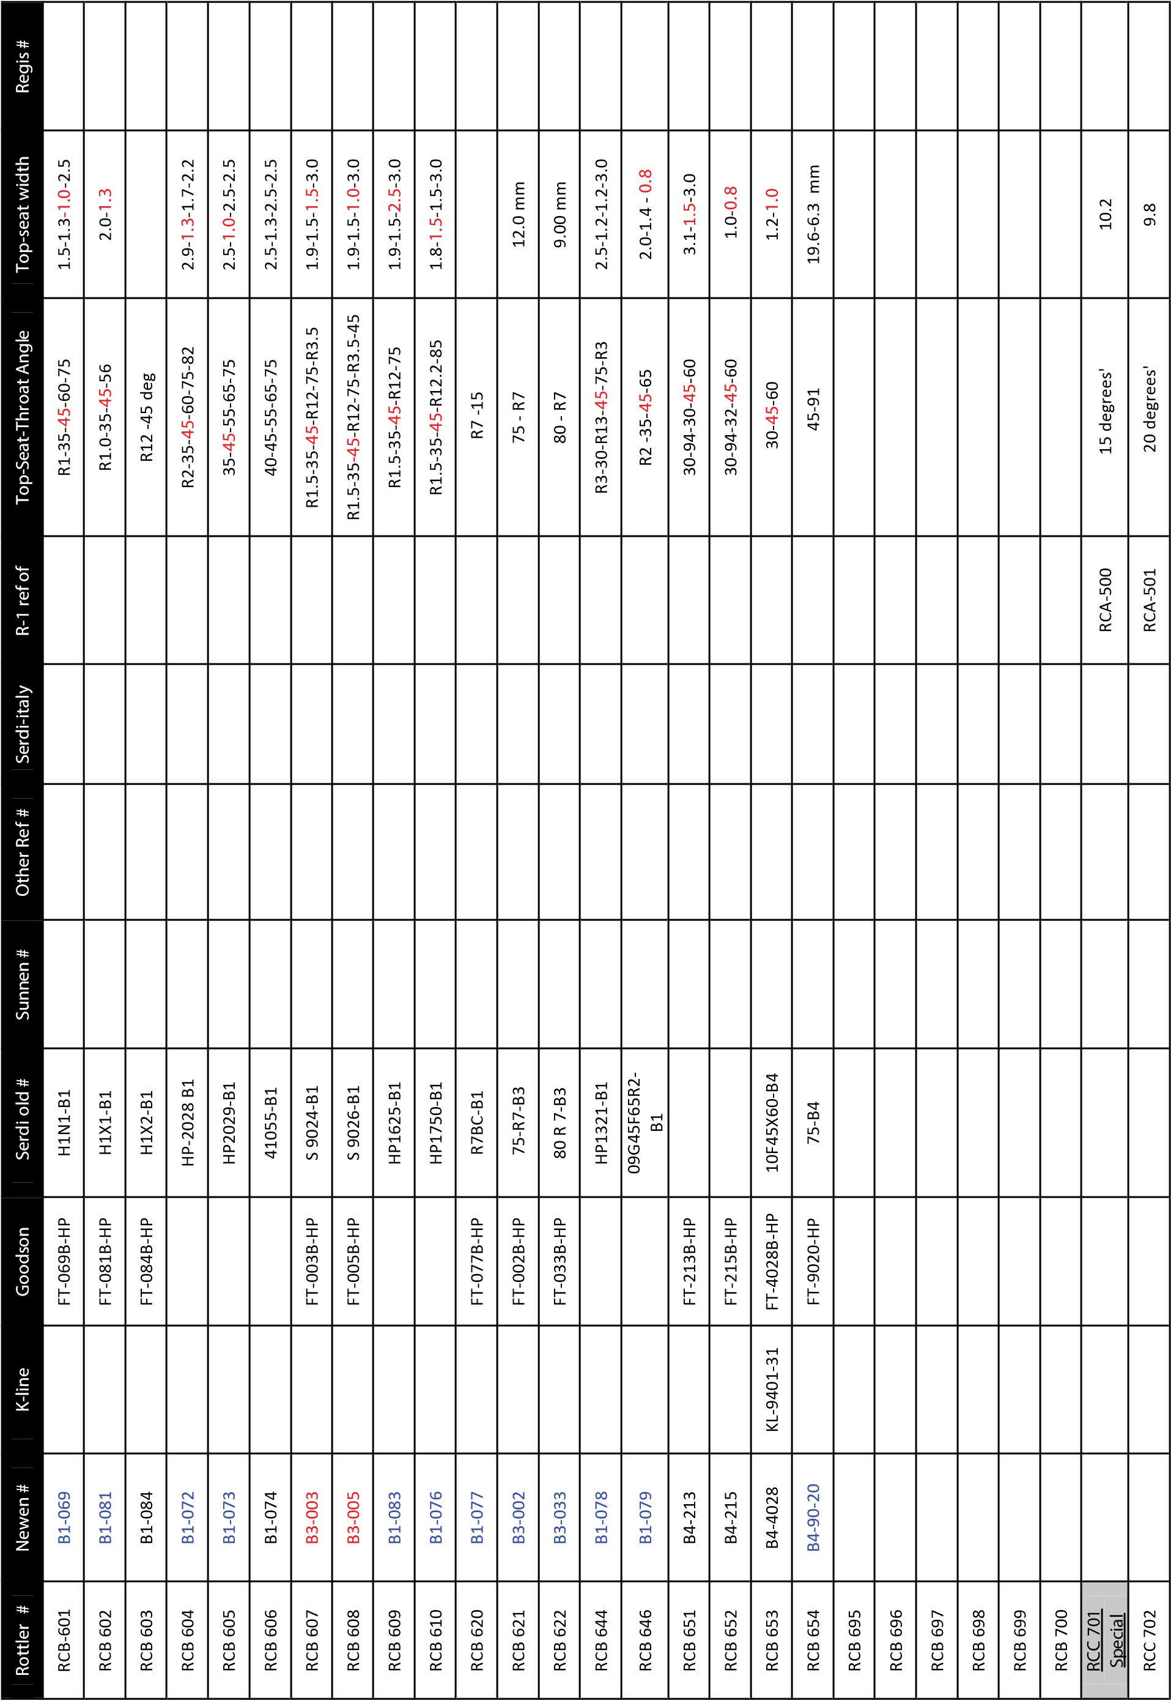

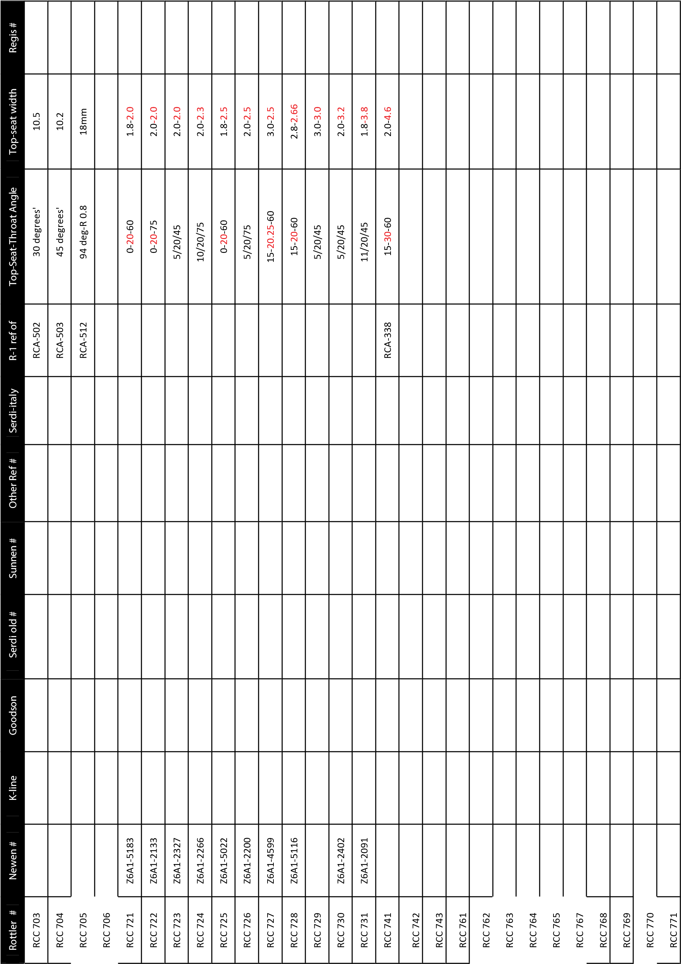

## Custom Insert Profile Order Form

